UNIVERSITA’ DEGLI STUDI DI PARMA

Dottorato di ricerca in Ingegneria Industriale

Ciclo XXVIII

Numerical Optimization of Heat Transfer in Tree-Like Assemblies of Fins

Coordinatore:
Chiar.mo Prof. Marco Spiga

Tutor:
Chiar.mo Prof. Giulio Lorenzini

Dottorando: Ing. Marco Medici

Table of contents

Nomenclature | p.3
Preface | 5
List of Figures | 7
List of Tables | 9
Acknowledgements | 11
1. Overview on heat transfer
1.1 Introduction | 13
1.2 Modes of heat transfer | 15
1.3 Heat conduction concepts | 18
1.4 The heat conduction equation | 20
1.5 The well-posed problem | 21
1.6 One-dimensional steady heat conduction | 23
1.7 Thermal resistance | 26
1.8 Dimensional analysis | 27
References | 29
2. Fin design
2.1 The practical purpose of fins | 31
2.2 Common practices in fin design | 32
2.3 Analysis of a one-dimensional fin | 33
2.4 Measures of fin performance | 39
References | 40
3. T-shaped conductive fins
3.1 Analysis of the “T” assembly | 41
3.2 Literature review | 42
3.3 Numerical modelling of T-shaped fins | 43
3.4 Method and tests | 45
3.5 Results and discussion | 47
References | 54
4. Y-shaped conductive fins
4.1 Analysis of the “Y” assembly | 55
4.2 Literature review | 57
4.3 Numerical modelling of T-shaped fins | 57
4.4 Method and tests | 58
4.5 Results and discussion | 60
References | 65
5. Convective heat transfer
5.1 Boundary layers | 67
5.2 Conservation laws | 70
References | 71
6. Y-shaped convective fins
6.1 Introduction | 73
6.2 Literature review | 74
6.3 Convective environment | 75
6.4 Conjugate heat transfer in laminar flow conditions | 77
6.5 Conjugate heat transfer in turbulent flow conditions | 99
References | 109
7. Conclusions
7.1 Final remarks | 111

Nomenclature

a | Fin design parameter | (-)
A | Area | (m²)
Bi | Biot number | (-)
c_{p} | Specific heat capacity at constant pressure | (J/Kg K)
c_{v} | Specific heat capacity at constant volume | (J/Kg K)
e | Radiative heat flux | (W/m²)
f | Mass force | (N/kg)
F | Stress force | (N/m²)
h | Heat transfer coefficient | (W/m² K)
H | Enthalpy | (J)
k | Thermal conductivity | (W/m K)
L | Length | (m)
m | Mass | (kg)
m | Fin design parameter | (m⁻¹)
Nu | Nusselt number | (-)
p | Pressure | (Pa)
P | Perimeter | (m)
Pe | Péclét number | (-)
Pr | Prandtl number | (-)
q | Heat flux | (W/m²)
Q | Heat transfer rate | (W)
Re | Reynolds number | (-)
S | Surface area | (m²)
t | Thickness | (m)
T | Temperature | (K)
u | Velocity | (m/s)
U | Internal thermal energy | (J)
V | Volume | (m³)
W | Width | (m)
Greek letters
α | Fin design parameter | (°)
γ | Ratio of specific heats | (-)
δ | Boundary layer thickness | (μm)
ε | Effectiveness | (-)
η | Efficiency | (%)
μ | Dynamic viscosity | (kg/m s)
θ | Dimensionless temperature | (-)
σ | Stefan-Boltzmann constant | (W/m² K⁴)
ρ | Mass density | (kg/m³)
υ | Viscous diffusion rate | (m²/s)
φ | Fin volume fraction | (-)
Subscripts
b | Reference value
f | Fin
g | Heat generation
t | Thermal
∞ | Reference value
w/o | without
Superscripts
– | Average value
→ | Vector
~ | Dimensionless
Acronyms
b.c. | Boundary condition
b.l. | Boundary layer
i.c. | Initial condition

Preface

The aim of this work was to study the heat transfer performance of T-shaped and Y-shaped assemblies of fins. Y and T shape elements represent tree-shaped structures that promise a more homogeneous distribution of transport phenomena. Literature offers a large variety of architecture optimization of such assemblies, and they have been adopted in several applications in order to improve the performance of fluid networks and heat exchangers.
Initially treated in literature in the context of pure heat conduction, T and Y-shaped fins were progressively studied also in natural and forced convection environments depending on the particular case considered. At this regard, a similar conceptual path is adopted in this work.
In Chapter 1, after recalling the modes of heat transfer, a in-depth analysis of heat conduction is performed, describing at the same time how to correctly pose a heat conduction problem in order to be solved. The dimensional analysis is hence introduced as essential tool to analyze the behaviour of heat transfer systems. The appropriate dimensionless groups that characterize the transport phenomena are gradually introduced in the work, when the particular case-bond analysis requires them. The main characteristics of the fin design is discussed in Chapter 2, in which dimensiolization helps also to solve common energy balances related to traditional fins. Chapter 3 and Chapter 4 are devoted to the study of T and Y shape assemblies in a pure conduction environment. The numerical investigations performed through a finite element analysis have proved, at first, to be aligned to those obtained through Constructal theory. In Chapter 5 we cite some preparatory arguments such as boundary layers and conservation laws and in Chapter 6 a conjugate heat transfer modelling is performed; the assemblies of fins studied have several degrees of freedom and include different flow conditions. The main results of this investigation was the evidence that the optimal assembly shape is strictly related to the characteristics of the convective environment to which the fin is subjected. Finally, in Chapter 7 we summarize the fundamental results obtained throughout this experience and propose future developments about the study and the application of tree-shaped assembly of fins.

List of Figures

1.1 | The temperature dependence of the thermal conductivity of metallic solids | p.19
1.2 | A transient cooling of a body subjected to b.c.’s of the first, second and third kind | 22
2.1 | Some of the many varieties of finned tubes | 31
2.2 | Sketch of a one-dimensional fin | 34
2.3 | Temperature distribution and dimensionless heat flux in one-dimensional fin with tip insulated | 37
3.1 | T-shaped assembly of plate fins | 42
3.2 | Initial conditions and b.c.’s for the numerical T-shaped fin problem | 44
3.3 | A sample mesh refinement for the T-shaped fins modelling | 45
3.4 | Dimensionless heat flux for various T-shaped assemblies of fins | 49
3.5 | Optimal T-shaped fins at $φ$ = 0.11 (a) and $φ$ = 0.20 (b) | 50
3.6 | The dependence of the heat transfer coefficient on the geometry of the assembly | 51
3.7 | Fin effectiveness of T-shaped fins | 51
4.1 | Y-shaped assembly of plate fins | 56
4.2 | Initial conditions and b.c.’s for the numerical Y-shaped fin problem | 58
4.3 | A sample mesh refinement for the Y-shaped fins modelling | 59
4.4 | Dimensionless heat current for Y-shaped fins at φ = 0.11 | 61
4.5 | Dimensionless heat current for Y-shaped fins at φ = 0.13 | 62
4.6 | Dimensionless heat current for Y-shaped fins at φ = 0.15 | 62
4.7 | Dimensionless heat current for Y-shaped fins at φ = 0.17 | 63
4.8 | Dimensionless heat current for Y-shaped fins at φ = 0.19 | 63
4.9 | Variation of the geometric parameter L₀ with the angle α | 64
4.10 | Optimal Y-shaped fins at $φ$ = 0.15 for $α$ = 73° (a) and $α$ = 88° (b) | 66
5.1 | A momentum boundary layer | 67
5.2 | A thermal boundary layer over a warm surface | 68
6.1 | Schematic diagram of a single channel with Y-shaped fin | 76
6.2 | A sample mesh refinement for the convective Y-shaped fins modelling | 80
6.3 | Domain temperature for Cases 1-3 | 82
6.4 | Domain velocity for Cases 1-3 | 83
6.5 | Domain temperature for Cases 4-6 | 85
6.6 | Domain velocity for Cases 4-6 | 86
6.7 | Domain temperature for Cases 7-9 | 88
6.8 | Domain velocity for Cases 7-9 | 89
6.9 | Domain temperature for Cases 10-12 | 91
6.10 | Domain temperature for Cases 10-12 | 92
6.11 | Domain temperature for Cases 13-15 | 94
6.12 | Domain velocity for Cases 13-15 | 95
6.13 | Domain temperature for Cases 16-18 | 97
6.14 | Domain velocity for Cases 16-18 | 98
6.15 | Dimensionless heat flux for Y-shaped convective fins - Laminar flow | 99
6.16 | Domain temperature for Cases 19-21 | 102
6.17 | Domain velocity for Cases 19-21 | 103
6.18 | Velocity streamlines (φ = 0.15, u = 5 m/s) | 104
6.19 | Domain temperature for Cases 22-24 | 106
6.20 | Domain velocity for Cases 22-24 | 107
6.21 | Velocity streamlines (φ = 0.15, u = 7 m/s) | 108
6.22 | Dimensionless heat flux for Y-shaped convective fins - Laminar and turbulent flow | 108
7.1 | Comparison between conductive and convective fins | 113
7.2 | The average Nusselt numbers of Y-shaped convective fins with Reynolds number | 114

List of Tables

3.1 | Geometric parameters for T-shaped fins simulations | p.46
3.2 | Dimensionless heat flux for T-shaped assemblies | 48
3.3 | Thermal performance of optimal T-shaped assemblies | 52
4.1 | Geometric parameters for Y-shaped fins simulations | 59
4.2 | Dimensionless heat flux for Y-shaped assemblies | 60
4.3 | Heat transfer coefficient for Y-shaped assemblies | 65
4.4 | Fin effectiveness for Y-shaped and T-shaped assemblies | 65
6.1 | Geometric parameters for convective Y-shaped fins simulations | 77
6.2 | Reference properties for modelled materials | 79
6.3 | Numerical results for Cases 1-3 | 81
6.4 | Numerical results for Cases 4-6 | 84
6.5 | Numerical results for Cases 7-9 | 87
6.6 | Numerical results for Cases 10-12 | 90
6.7 | Numerical results for Cases 13-15 | 93
6.8 | Numerical results for Cases 16-18 | 96
6.9 | Numerical results for Cases 19-21 | 101
6.10 | Numerical results for Cases 21-24 | 105

Acknowledgments

I would like to express my deep gratitude to all those who gave me the possibility to carry out this thesis.
I want to thank my supervisor, Prof. Giulio Lorenzini, for his important support during the past three years; his experience and particular personality represented a special guidance for this work.
I sincerely thank Prof. Nicola Del Monte for his help and his precious advices. His passion for scientific research and his availability have been very important to complete this work.
I want to thank Prof. Adrian Bejan, for his special support and kind availability during the work.
I wish to thank Ing. Claudia Cognigni for helping me in CAD issues.
I am grateful to Luca Bergonzi and to Michele Zenna for their availability and their technical support.
I have to thank also Prof. Marco Spiga, coordinator of XXVIII cycle of the Ph.D course of Industrial Engineering, University of Parma.
Many thanks to all my colleagues for their support. My deepest gratitude goes to my family and especially to my mother, who had always provided a loving support to my work.

1

Overview on heat transfer

1.1 Introduction
We can recognize heat as a form of energy, even if cannot rely on an exact definition of the latter. We can define it only indirectly, using the so called law of conservation: energy is a certain quantity that does not change in the manifold changes of the nature. Even if heat can be recognized as being part of this quantity, it is definitely hard to define it, because its primary definition deals with something that is quite abstract, arising only through a mathematical principle. People have always recognized heat as something that flows from hot objects to cold objects; until the early nineteenth century, scientist named this flow as caloric, defining it as an invisible fluid. Heat really exists or happens by virtue of some differences in temperature, and this implies a lot of existential considerations. But, at the moment, it is sufficient to recognize that heat swaps, it is exchangeable among bodies, and thermodynamics provides the means and the constraints through which this happens. Thermodynamics begins with the study of the way that one does work with heat. Nowadays the subject of thermodynamics is quite clear; taking the R. Feynman suggestion, it is “the determination of the relationship among the various properties of materials independently of their molecular model”. A relevant statement for the purpose of this work, as the adopted points of view through which the various heat transfer phenomena are considered are related, at the limit, to the smallest significant dimension of the problem, without deepening into the atomic magnitude. Indeed, a lot of relationship among the properties of the materials can be worked out without analyzing the detailed structure of the matter, and this is, at the same time, the pros and the cons of the science of thermodynamics. More pros, actually, for the aims of this work.
A thermodynamic analysis starts with the division of the space into two entities: the system and the environment, which is portion of space located outside the system. The surface that limits the system from the environment is called boundary. We can distinguish an open system, which is permeable to both energy and mass, from a closed system whose boundary is prohibitive to mass transfer. The total energy of an isolated system composed by an open/closed system together with the surrounding environment remains constant, as stated by the law of conservation of energy. Energy can be neither created nor be destroyed, but anyhow it transforms from one form to another, and the other laws of thermodynamics constitute the general restrictions to which the transformations must be conform to. The First Law of Thermodynamics for a closed system takes the following form:
$Q=W+\frac{dU}{dt}$ (1.1)
where $Q$ is the heat transfer rate (positive toward the system), $W$ is the work transfer rate (positive away from the system), and $dU/dt$ is the rate of change of internal thermal energy (positive when the system’s energy increases). The First Law recognizes, besides restating the conservation principle, the equivalence between different forms of energy (heat and work) and the existence of the internal energy, which is a function describing quantitatively the equilibrium state of the system (state function); in contrast, heat and work are called process quantities because their values depend on the specific transition between two equilibrium states. In the analysis of real systems, frequently the heat transfer can be combined to some work process. If $p dV$ (i.e. the work necessary to compress a substance) is the only work that occurs, then Eq.(1.1) con be written as:
$Q=p\frac{dV}{dt}+\frac{dU}{dt}$ (1.2)
This equation can be re-adapted according to two specific cases:
Constant volume process: $Q=\frac{dU}{dt}=mc_{v}\frac{dT}{dt}$ (1.2a)
Constant pressure process: $Q=\frac{dH}{dt}=mc_{p}\frac{dT}{dt}$ (1.2b)
where $H=U+pV$ is the enthalpy, a state function, and $c_{v}$ and $c_{p}$ (J/Kg K) are, respectively, the specific heat capacities at constant volume and constant pressure. When, during an incompressible process, the volume of the (closed) system remains constant (i.e. isochoric process), the specific heats coincide: $c_{v}$ = $c_{p}$ = $c$, and Eq.(1.2) can be re-written as:
$Q=\frac{dU}{dt}=mc\frac{dT}{dt}$ (1.3)
This form is useful whenever there is no work transfer between an incompressible closed system and the environment.

1.2 Modes of heat transfer
At the macroscopic level, the fundamental modes of heat transfer are: heat conduction, which is the principle mechanism by which solids and stationary fluids transfer heat, heat convection, which is due to fluid motion, and thermal radiation, generated by the thermal motion of charged particles in matter.

Heat conduction
Thermal diffusion through solids and stationary fluids respects the Fourier’s law. Joseph Fourier defined the thermal conduction observing empirically that the heat transfer rate $Q$ (W) per unit area $A$ (m²) is proportional to the magnitude of the temperature gradient and opposite in sign. We can write this law in one-dimensional form as:
$q=-k\frac{dT}{dx}$ (1.4)
where $q$ (W/m²) is the heat flux, $k$ (W/m K) the thermal conductivity of the medium. If temperature increases with $x$, $q$ will be negative, and vice-versa, as $dT/dx$ is positive if $T$ increases while $q$ is a vector oriented from higher temperatures to lower ones; the three-dimensional form is developed and discussed in the next sections.

Heat convection
Consider a gas flowing over a warmer body. Isaac Newton suggested that the cooling should act like:
$\frac{dT_{body}}{dt}∝T_{body}-T_{∞}$ (1.5)
where $T_{∞}$ is the temperature of oncoming fluid. In case of steady state, the energy flowing from the body can be firstly assessed using Eq.(1.3):
$Q∝T_{body}-T_{∞}$ (1.6)
And, using the heat flux $q$ = $Q/A$:
$q=\overline{h}(T_{body}-T_{∞})$ (1.7)
where $\overline{h}$ is the heat transfer coefficient (W/m² K). Actually, with respect to $k$, $\overline{h}$ may vary even in case of homogeneous medium. Normally in engineering problems equations are carried out creating relationship between two physical quantities by means of a coefficient. In this case the use of $\overline{h}$ permits to balance the books, but the exact calculation of the heat transfer coefficient is definitely complex. We introduce this task in Chapter 6, and for the moment it is just worth to say that $\overline{h}$ is a mean value weighted at the convective boundary:
$\overline{h}=\frac{1}{A}∫_{A}h dA$ (1.8)

Thermal radiation
The radiative heat transfer is a mode of transferring heat in the form of electromagnetic waves. It is, for instance, the means by which the sun supplies solar energy to the earth. Electromagnetic radiation can propagate through solids, liquids, gases and travel through vacuum as well. It consists of two fields, one electrical, the other magnetic, that move together at the speed of light. The intensity of each field oscillates to the direction of wave propagation. The number of these oscillations per second is defined frequency $ν$ (Hz). The distance travelled to complete a single oscillation cycle is the wavelength $λ$ (μm), which depends also on the medium. Electromagnetic wavelengths can vary from 10⁻¹³ m for cosmic rays to 10⁶ m for extremely long radio waves. However, heat is only a small part of this range. Indeed thermal radiation varies from 10⁻⁷ m to 10⁻³ m, including the ultraviolet light (0.2 – 0.4 μm), the visible light (0.4 – 0.7 μm), and the infrared radiation (0.7 – 1000 μm). For example, the sun’s total output power at the earth ground level mostly consist of infrared (52 – 55%), visible light (42 – 43%), and ultraviolet (3 – 5%). The solar spectrum can be approximated to a continuous line, i.e. that one corresponding to a black body at 5250°C. A black body is a perfect thermal emitter which means that it absorbs all the energy that reaches it and reflects nor transmits nothing. With refer to such body, Wien discovered empirically a relation between the radiant energy and the wavelength, at a given temperature, stating that the black body radiation curve peaks at a wavelength inversely proportional to the temperature:
$λ_{max}=\frac{b}{T}$ (1.9)
where $b$ is a constant called Wien’s displacement constant, equal to about 2900 μm K.
The flux of energy radiating from whatever body can be assessed by means of Stefan-Boltzmann law. This is based on the distribution function of the radiative flux $e_{λ}\left(λ,T\right)$ which depends on the body temperature and the wavelength. For a black body, it takes the form:
$e_{black}\left(T\right)=σT^{4}$ (1.10)
where the Stefan-Boltzmann constant, $σ$, is 5.67 ∙ 10⁻⁸ W/m² K⁴. We can characterize the emissive power as well as for a non-black body using a property called emittance, $ε$:
$e\left(T\right)=εσT^{4}$ (1.11)
where 0 $<$ $ε$ $≤$ 1; clearly, non-black bodies emit less radiation than black bodies. Given the fact that all the bodies emit a certain amount of radiative energy, in evaluating the heat transferred between two bodies it is necessary to take into account only the net energy transferred that is hence proportional to $\left|T_{body1}^{4}-T_{body2}^{4}\right|$. It is clear how the intensity of the thermal radiation depends upon the temperature of the body and the type of surface. Often, in many engineering applications, the contribute of the radiative heat transfer can be neglected in comparison with conduction and convection since the temperatures of the system are not particularly high and the emittance of the elements involved is quite distant from the black body condition.

1.3 Heat conduction concepts

Consider a three-dimensional body heated from one arbitrary side. In this case the temperature of the body varies with time and space: $T=T(x,y,z,t)$. An important vector associated with the scalar $T$ is called temperature gradient $∇T$:
$∇T=\vec{i}\frac{∂T}{∂x}+\vec{j}\frac{∂T}{∂y}+\vec{k}\frac{∂T}{∂z}$ (1.12)
The vector $∇T$, as its definition proves, has magnitude and direction of the maximum increase of temperature at each point of the body, in which various isothermal surfaces $T_{1}$, $T_{2}$, $T_{3}$, $T_{4}$, etc… may be found. Next consider that the heat flow $\vec{q}$ precisely results from these different temperatures. In particular, $\vec{q}$ and $∇T$ are exactly opposite one another in direction, and the magnitude of the heat flux is directly proportional to the temperature gradient:
- $\frac{\vec{q} }{\left|\vec{q} \right|}=-\frac{∇T}{\left|∇T\right|}$
- $\left|\vec{q} \right|∝\left|∇T\right|$
Fourier’s law summarizes these evidences as:
$\vec{q}=-k∇T$ 1.13)
Which split along the axis can be written as:
$q_{x}=-k\frac{∂T}{∂x}$ $q_{y}=-k\frac{∂T}{∂y}$ $q_{z}=-k\frac{∂T}{∂z}$
This empirical law formulated in 1822 is considered the beginning of the modern theory of heat conduction. The heat flux is hence a vector quantity, which is positive (negative) if temperature decreases (increases), as $q$ flows from higher temperatures to lower temperatures. The positive number $k$ is the so-called thermal conductivity that depends generally on both position and temperature:
$k=k[T,x,y,z]$ (1.14)
However, most materials can be considered nearly homogeneous, thus we can pose $k=k(T)$. The assumption that $k$ is constant also with temperature is quite defective and generally wrong. However we can consider $k$ approximately constant only for some materials, mainly solids, and in determined ranges of interest. For example, we could take $k$ as a constant for aluminum between 20° and 200°C. Figure 1.1 shows the temperature dependence of thermal conductivity of some common materials. Also, in steady conditions, if $k$ varies linearly within the interested range $∆T$, we can choose $k$ evaluated at the average temperature. And, if $k$ varies definitely not linearly, one can still use a constant average of $k$, provided that $∆T$ is not large. With refer to the state of matter, generally solids show the highest thermal conductivity, while gases the lowest ones. The thermal conductivity is also a function of location: for isotropic materials, $k$ is the same in all directions, but for anisotropic materials like, for example, wood and laminated materials, $k$ varies much more in a single direction.
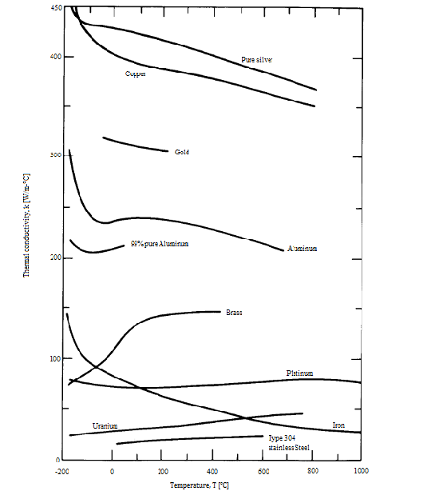

Figure 1.1. The temperature dependence of the thermal conductivity of metallic solids

(Adapted from Lienhard, 2015)

1.4 The heat conduction equation
We can now write the heat conduction equation in three dimensions, after recalling the First Law statement, without considering any dynamical force contribute, which is irrelevant for the present dissertation:
$Q=\frac{dU}{dt}$ (1.15)
We can assume a control volume $V$ (i.e. a finite region of a conductive body) enclosed into a surface $S$. Each element of the surface, $dS$, is identified by its own unit normal vector, $\vec{n}$, and is crossed by the heat flux $\vec{q}=-k∇T$. We can write the heat conducted out of $dS$, in watts, as:
$-k∇T∙(\vec{n}dS)$ (1.16)
Provided that a volumetric heat generation $q_{g}$ (W/m³) is present within $V$, a heat transfer balance equation for the control volume can be written as:
$Q=-\int_{S}{\left(-k∇T\right)}∙\left(\vec{n}dS\right)+\int_{V}{q_{g}dV}$ (1.17)
The rate of internal energy increase of $V$ is:
$\frac{dU}{dt}=\int_{V}{\left(ρc\frac{∂T}{∂t}\right)dV}$ (1.18)
Note that the derivative of $T$ is partial, being function of both time and space. Combining $Q$ from Eq.(1.15) and $dU/dt$ from Eq.(1.18) into Eq.(1.17), one obtain:
$\int_{S}{k∇T}∙\vec{n}dS=\int_{V}{\left[ρc\frac{∂T}{∂t}-q_{g}\right]dV}$ (1.19)
Gauss’s theorem permits to make Eq.(1.19) uniform by converting the surface integral into a volume integral. After rearranging, we obtain:
$\int_{V}{\left(∇∙k∇T-ρc\frac{∂T}{∂t}+q_{g}\right)dV}=0$ (1.20)
Since the volume $V$ is arbitrary, the integrand must vanish identically:
$∇∙k∇T+q_{g}=ρc\frac{∂T}{∂t}$ (1.21)
Eq.(1.21) is the heat diffusion equation in three dimensions, which is a partial differential equation. It is valid only in case of incompressible medium ($ρ$ = const.) and no convection. Indeed if the medium changes its position in time, one should consider also the rate of internal energy increase in time due to velocity, which leads to the diffusion equation (see Chapter 5). If the variation of $k$ with $T$ is small, one can pose:
$∇^{2}T+\frac{q_{g}}{k}=\frac{ρc}{k}\frac{∂T}{∂t}$ (1.22)
The ratio $k/ρc$ (m²/s) is usually defined as thermal diffusivity. This is a measure of how quickly a material can carry heat away from an hot spot; high values denote a quick heat propagation whereas a low value indicates that the heat is mostly stored within the matter. Also, a high value for the volumetric heat capacity $ρc$ (J/m³ K) is associated to a low value of thermal diffusivity whereas high-conductivity materials denote high values.

1.5 The well-posed problem
To find the temperature distribution within a certain region arbitrary extended, it is necessary to solve the heat diffusion equation. An heat conduction problem can be read as follows. For assigned time ($0<t<τ$) and space ($(x,y,z)∈S$), find $T(x,y,z,t)$ such that:

1. $∇^{2}T+\frac{q_{g}}{k}=\frac{ρc}{k}\frac{∂T}{∂t}$
2. $T=T_{0}(x,y,z)$ at $t=0$
This is called initial condition (i.c.), which prescribes the body temperature at time t = 0. However, such condition is not needed in case of steady state ($∂T/∂t$ = 0).

3. $T$ must satisfy two boundary conditions (b.c.’s) for each coordinate. There are three types of b.c.’s:
- Dirichlet conditions or constant surface temperature (b.c.’s of the first kind): $T$ is specified on the boundary of $S$ for $t>0$.
- Neumann conditions or constant surface heat flux (b.c.’s of the second kind): The spatial derivative of $T$ normal to the boundary is specified for $t>0.$
- b.c.’s of the third kind: A spatial derivative of $T$ normal to a boundary is proportional to the temperature on that boundary. This typical way adopted when the convective heat transfer is handled as boundary condition:
${\left.-k\frac{∂T}{∂x}\right|}_{boundary}=\overline{h}{(T-T_{∞})}_{boundary}$
Figure 1.2 shows the transient cooling of a body subjected to each of the b.c.’s just described. Note that the initial temperature $T_{0}$ is not subjected to the boundary conditions, as it is imposed only at t = 0. Once the heat conduction problem has been posed, it is possible to find the general solution of the heat diffusion equation. Some examples of general solutions are following reported.

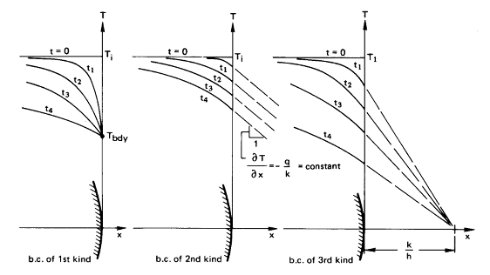

Figure 1.2. A transient cooling of a body subjected to b.c.’s of the first, second and third kind
(Source: Lienhard, 2015)

1.6 One-dimensional steady heat conduction
We consider now some common steady conduction examples in order to obtain expressions for both the temperature distribution and the rate of heat transfer. For each of the following cases the heat diffusion equation takes the form:
$∇^{2}T=-\frac{q_{g}}{k}$ (1.23)

Plane slab
Consider a plane slab of thickness $L$ made of thermal conductive material. The temperatures at the sides of the slab are respectively,$T_{0}$ and $T_{1}$, with $T_{0}>T_{1}$. In case of no heat generation within the slab, and considering only the heat diffusion along the x-axis, Eq.(1.23) can be re-written in the form:
$\frac{∂^{2}T}{∂x^{2}}=0$
Integrating it twice one can get:
$T=c_{1}x+c_{2}$
The constants $c_{1}$ and $c_{2}$ can be determined by means of b.c.’s of the first kind: $T\left(x=0\right)=T_{0}$, and $T\left(x=L\right)=T_{1}$, so that:
$c_{2}=T_{0}$ and $c_{1}=(T_{1}-T_{0})/L$
The (linear) temperature distribution results as:
$T=(T_{1}-T_{0})\frac{x}{L}+T_{0}$
And the application of the Fourier’s law gives:
$q_{x}=-k\frac{∂T}{∂x}$ → $q_{x}=k\frac{(T_{0}-T_{1})}{L}$

Plane slab with internal energy generation
In this case the same plane slab generates heat, so the appropriate form for the heat diffusion equation is:
$\frac{∂^{2}T}{∂x^{2}}=-\frac{q_{g}}{k}$
And, integrating it twice one can get:
$T=-\frac{q_{g}}{2k}x^{2}+c_{1}x+c_{2}$
Where the constants $c_{1}$ and $c_{2}$ can be still determined by means of b.c.’s of the first kind:
$c_{2}=T_{0}$ and $c_{1}=\frac{T_{1}-T_{0}}{L}+\frac{q_{g}}{2k}L$
The temperature distribution, which is parabolic, is given as:
$T=-\frac{q_{g}}{2k}x^{2}+\left(\frac{T_{1}-T_{0}}{L}+\frac{q_{g}}{2k}L\right)x+T_{0}$
The heat flow along the x-axis is given by the Fourier’s law:
$q_{x}=-k\frac{∂T}{∂x}$ → $q_{x}=q_{g}\left(x-\frac{L}{2}\right)+\frac{\left(T_{0}-T_{1}\right)k}{L}$

Hollow cylinder
Consider a hollow cylinder of internal radius $r_{1}$, external radius $r_{2}$, length $L$. The inside and outside temperatures are, respectively,$T_{1}$ and $T_{2}$, with $T_{1}>T_{2}$. In case of constant thermal conductivity and no heat generation within the cylinder, Eq.(1.23) can be re-arranged as:
$\frac{1}{r}\frac{d}{dr}\left(r\frac{dT}{dr}\right)=0$
Integrating it twice one can obtain:
$T=c_{1}\ln{r}+c_{2}$
The constants $c_{1}$ and $c_{2}$ can be determined by using the following b.c.’s of the first kind: $T\left(r=r_{1}\right)=T_{1}$, and $T\left(r=r_{2}\right)=T_{2}$, so that:
$c_{1}=\frac{T_{1}-T_{2}}{\ln{r_{2}/r_{1}}}$ and $c_{2}=T_{2}-\frac{T_{1}-T_{2}}{\ln{r_{2}/r_{1}}}\ln{r_{2}}$
The temperature distribution within the material along the radial direction is hence given by:
$T=\frac{T_{1}-T_{2}}{\ln{r_{2}/r_{1}}}\ln{r/r_{2}}+T_{2}$
The heat flow is given by the Fourier’s law:
$q_{r}=-k\frac{dT}{dr}=k\frac{T_{2}-T_{1}}{\ln{r_{2}/r_{1}}}\frac{1}{r}$
And, extending the heat flow for the whole length of the cylinder one can obtain the thermal power $Q$ (W):
$Q=(2πrL)q_{r}=\frac{2πkL(T_{2}-T_{1})}{\ln{r_{2}/r_{1}}}$ (1.24)

Hollow cylinder with external fluid
The same hollow cylinder is here analyzed, this time the external surface is considered bathed by an oncoming fluid. A convective heat transfer coefficient $\overline{h}$ around the outside of the cylinder can be used. The temperature profile can be obtained integrating twice the heat diffusion equation along radial direction:
$T=c_{1}\ln{r}+c_{2}$
A first boundary condition can be posed as: $T\left(r=r_{1}\right)=T_{1}$. Then, a second boundary condition can be expressed in terms of thermal balance at the outer surface (b.c. of the third kind):
${\left.-k\frac{∂T}{∂r}\right|}_{r=r_{2}}=\overline{h}{(T-T_{∞})}_{r=r_{2}}$ (1.25)
And, substituting:
${-k\left[\frac{d}{dr}(c_{1}\ln{r}+c_{2}-T_{∞})\right]}_{r=r_{2}}=\overline{h}{[c_{1}\ln{r}+c_{2}-T_{∞}]}_{r=r_{2}}$ →
$\frac{kc_{1}}{r_{2}}=\overline{h}(T_{∞}-c_{1}\ln{r_{2}}-c_{2})$
Combining the two b.c.’s:
$c_{1}=-\frac{T_{1}-T_{∞}}{\frac{k}{{\overline{h}r}_{2}}+ln(r_{2}/r_{1})}$
$c_{2}=T_{1}-\frac{T_{∞}-T_{1}}{\frac{{\overline{h}r}_{2}}{k}+ln(r_{2}/r_{1})}\ln{r_{1}}$
The temperature profile is hence given by:
$T=\frac{T_{∞}-T_{1}}{\frac{{\overline{h}r}_{2}}{k}+ln(r_{2}/r_{1})}ln{(r/r}_{1})+T_{1}$
Then, the heat flow can be assessed as:
$q_{r}=-k\frac{dT}{dr}=k\frac{T_{1}-T_{∞}}{\frac{k}{{\overline{h}r}_{2}}+ln(r_{2}/r_{1})}\frac{1}{r}$
This can be written in terms of $Q$ (W):
$Q=\left(2πrL\right)q_{r}=\frac{T_{1}-T_{∞}}{\frac{1}{{\overline{h}2πr}_{2}L}+\frac{ln(r_{2}/r_{1})}{2πkL}}$ (1.26)

1.7 Thermal resistance
Thermal resistance is defined as the ratio of the temperature difference to the related rate of heat transfer, in perfect analogy to electrical resistance that is defined as the ratio of the voltage difference to the current flow, as Ohm’s law states. With regards to the heat conduction in a plane slab throw a surface $A$, and a hollow cylinder as previously defined, we can rearrange the heat conduction equations as, respectively:
$Q=\frac{∆T}{L/kA}$ (1.27)
$Q=\frac{2πkL∆T}{\ln{r_{2}/r_{1}}}$ (1.28)
Where $L/kA$ and $\frac{\ln{r_{2}/r_{1}}}{2πkL}$ assume the role of thermal resistances $R$ (K/W). When convection occurs at the boundary of a solid and can be handled as boundary condition, the convection resistance can be deduced by Newton’s law (Eq.(1.7)):
$R_{conv}=\frac{1}{\overline{h}A}$ (1.29)
Eq.(1.29) can be used also for a hollow cylinder; in this case $A$ is the surface area over which convection occurs, as Eq.(1.26) proves:
$R_{conv}=\frac{1}{\overline{h}A}=\frac{1}{\overline{h}2πrL}$ (1.30)
The thermal resistance definition is useful to analyze conductive heat transfer even through composite members.

1.8 Dimensional Analysis
Dimensional analysis gains a certain importance to heat transfer problems when they involve several variables. In this case dimensional methods help to reorganize variables into dimensionless groups, and, therefore, to reduce the number of variables. The non-dimensiolization permits also to consider and compare similar systems of heat transfer and to simplify the solving process. In this section the method of functional replacement derived from (Lienhard, 2015) is considered. Suppose that $y$ depends on $a,b,c$ etc.:
$y=y(a,b,c,…)$
Note that, since $y$ shows a functional dependence on the other parameters (and not an algebraic dependence), it is possible to arbitrarily rearrange the equations. Thus, we can multiply or divide of powers any variable without invalidating the former functional equation. For instance, the equation above can be rearranged as:
$\frac{y}{a}=\frac{y}{a}(a,a^{2}b,ac,…)$
That is, under a functional point of view, still correct because if $y$ depends on $a$, $b$ and $c$, then it will depend also upon$a$, $a^{2}b$ and $ac$. This simple fact constitutes the head of the Buckingham pi-theorem which can be stated in the following way: if there are $n$ variables expressed in $m$ dimensions, it is possible to express the equation in ($n$ - $m$) dimensionless groups. Buckingham identified the dimensionless groups as $π_{1}$, $π_{2}$, ... $π_{n-m}$. If we call $π_{1}$ the dependent variable, the dimensional functional equation reduces to a dimesionless one in the form:
$π_{1}=fn(π_{2},π_{3},…,π_{n-m})$ (1.31)
For instance, we perform now a non-dimensiolization, recalling the example of a hollow cylinder with external fluid shown in §1.6. The temperature profile was described by the following equation:
$T-T_{1}=\frac{T_{∞}-T_{1}}{\frac{{\overline{h}r}_{2}}{k}+ln(r_{2}/r_{1})}ln{(r/r}_{1})$
First, we write the dimensional functional equation:
$T-T_{1}=fn[r,r_{1}, r_{2},\overline{h},k,\left(T_{∞}-T_{1}\right)]$
There are seven variables ($n$ = 7), in three dimensions, K, m and W ($m$ = 3). Therefore there will be 4 dimensionless groups. We can obtain a first dimensionless group by dividing the first variable with the seventh:
$\frac{T-T_{1}}{T_{∞}-T_{1}}=fn[r,r_{1}, r_{2},\overline{h},k]$
Other dimensionless groups can be obtained rearranging the radius and the heat transfer coefficient:
$\frac{T-T_{1}}{T_{∞}-T_{1}}=fn[\frac{r}{r_{1}}, \frac{r_{2}}{r_{1}},\frac{\overline{h}r_{2}}{k}]$
Finally, the four pi-groups identified are:
$π_{1}=\frac{T-T_{1}}{T_{∞}-T_{1}}$, $π_{2}=\frac{r}{r_{1}}$, $π_{3}=\frac{r_{2}}{r_{1}}$, $π_{4}=\frac{\overline{h}r_{2}}{k}≡Bi$
The group $\overline{h}r_{2}/k$ is called the Biot number, $Bi$, which is often used in heat transfer calculations. It gives a measure of the ratio of the heat transfer resistances inside the body (1/$k$) and at the surface of the body ($1/\overline{h}r_{2}$). In general, the temperature field inside the body can be considered as uniform, i.e. the problems can be considered thermally simple, if $Bi≪$ 1, whereas Biot number much larger than 1 highlights non-uniformity of the temperature field within the object. Dimensional analysis will be performed in the next chapters, proving to be a very useful tool in solving heat transfer problems that will be undertaken.

References

A. Bejan, Advanced Engineering Thermodynamics, 3rd ed., John Wiley & Sons, New York, 2006.

A. Bejan, A.D. Kraus, Heat transfer Handbook, John Wiley & Sons, Hoboken, 2003.
R. Feynman, R. Leighton, M. Sands, The Feynman Lectures on Physics, Vol. 1, Pearson Education Inc., USA, 2006.
J. Lienhard IV, J. Lienhard V, A Heat Transfer Textbook, 4th ed., Phlogiston Press, Cambridge, MA, 2015.

W.M. Rohsenow, J.P. Hartnett, Handbook of Heat transfer, McGraw-Hill Company, New York, 1973.
Y. A. Ḉengel, Termodinamica e trasmissione del calore, McGraw-Hill Company, Milano, 1998.

2
Fin Design

2.1 The practical purpose of fins
In the study of heat transfer an extended surface allows to increase the rate of heat transfer between two environments at different temperatures. The rate of heat transfer increases with the increasing of the temperature difference between the environments, increasing the convection heat transfer coefficient, or increasing the surface area, as widely shown in the previous chapter. But, since in most cases it is not feasible to focus on temperature differences and heat transfer coefficient as they are fixed design parameters, working on heat transfer surfaces by mounting, for example, one or more metal fins on a surface is considered a good solution to heat transfer problems: in this case the temperature throughout the fin will approach that of the surrounding medium because of the high thermal conductivity of the fin itself, with the consequent improvement of the convective heat removal.
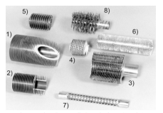
Examples of finned tubing: 1) and 2) typical fins of constant thickness; 3) and 4) serrated fins dimpled and spirally-wound fins; 5) spirally-wound copper coils; 6) and 8) bristle spirally-wound fins; 7) spirally indented tube
Figure 2.2. Some of the many varieties of finned tubes (Source: Lienhard, 2015)
Fins characterized by various shapes and made up of different materials can be employed onto exchanging surfaces depending on the particular application; nowadays the design of heat exchangers concerns industries like automotive, aerospace, refrigeration, air conditioning, air compression, and microelectronics, to name a few. Figure 2.1 shows just some of the ways in which a surface can be extended, defining what fins are.

2.2 Common practices in fin design
The extended surface literature from 1922 to 1987 has been reviewed by Kraus in 1988 (Kraus, 1988); after that, a state-of-the-art of the fins design and optimizing procedures has been proposed by Aziz (Aziz, 1992) and later, by Lienhard (Lienhard, 2011). Despite this last general contribute, nowadays it is objectively difficult to find similar large-scale contributes as scientific efforts are more focused on very specific cases and practical studies characterized by case-dependent settings. This trend is mainly due to the greater complexity toward which the technology is directed; at this regard, an example is the miniaturization evolution, according to which the space becomes a premium and the word compactness “strikes” the heat exchanger design: the challenge of small scale industry in terms of compact heat exchangers arise in 1980s and continues towards the near future, whose direction is clear. As Bejan and Kraus argued, “the many surfaces designed (...) are accomplishing the same thing: they are increasing the heat transfer rate density, the size of the heat transfer enterprise that is packed into a given volume” (Bejan, Kraus 2003).The optimal fin design is the one that allows the highest heat transfer for the minimum amount of material. At this regard, fin optimization problems can be classified into two main groups (Aziz 1992):
- Given a fin shape and a volume of material, find the optimal geometry that lead to maximum heat transfer;
- Given the desired heat dissipation, determine the optimal geometry so that the volume used is minimum.
This work, like the many several contributes in literature, focuses on the first group of problems, mainly for practical reasons, as the solutions for the second group of problems may result in curved or irregular shapes. In the analysis of the fin heat transfer, the following assumption are generally made:
- Steady-state operation
- Constant surrounding air temperature $T_{∞}$
- Homogeneous isotropic material, with thermal conductivity $k$
- No internal heat generation
- Convective heat transfer coefficient uniform along the fin surface $\overline{h}$
- Negligible thermal radiation
- The temperature of the heat transfer surface at the base of the fin is constant, $T_{b}$
- The maximum temperature driving force for convection is $T_{b}$ – $T_{∞}$
These general assumptions have been introduced in the previous chapter and, nevertheless, depending on the particular problem, other assumptions may need to be made. In order to show the main features of all fin behavior, the analysis of a straight fin protruding from a wall will be performed, and the related calculations are entirely based on the additional assumption that $Bi≪$ 1, which has been introduced in §1.8.

2.3 Analysis of a one-dimensional fin
With regard to Fig. 2.2, we can define a fin of length $L$, uniform cross-sectional area $A$ and external perimeter $P$. The root of the fin is at temperature $T_{b}$, which differs from the ambient temperature $T_{∞}$. Depending from the latter temperature, which can be greater or less than the root temperature, a heat transfer coefficient $\overline{h}$ defines the heating or cooling of the fin; we assume $T_{b}$ > $T_{∞}$. It is useful the define a characteristic dimension for the fin in the transverse direction. If the thickness is constant, the characteristic dimension can be taken as $A$/$P$, that, for a circular cylindrical fin it is equal to (radius/2). To treat the heat flow only along the x-axis (i.e. one-dimensional heat transfer), we have to demonstrate that the variation of $T$ along radial direction is much less than ($T_{b}$ – $T_{∞}$). Therefore, we define a Biot number in the transverse direction an require that it be small:
${Bi}_{fin}=\frac{\overline{h}(A/P)}{k}≪$ 1 (2.1)
Assuming that the condition above is largely satisfied, we can proceed to perform an energy balance on the thin slice of the fin shown in Fig. 2.2. The heat flow along x-axis in steady condition, therefore the thermal balance at the boundaries of the control volume is:
$Q_{in}=Q_{out}$
So, the energy flow inside the slice, due to heat conduction, must equal the energy flowing out of the slice, sum of heat conduction along x and heat convection through the external wall:
$Q_{in}=q_{x}$ $Q_{out}=q_{x+dx}+q_{conv}$
Being:
$q_{x}=-kA\frac{dT}{dx}$ $q_{x+dx}=q_{x}+\frac{dq_{x}}{dx}dx$ $q_{conv}=\overline{h}\left(Pδx\right)\left(T-T_{∞}\right)$
Therefore a thermal balance can be assessed as outlined by the following equation.
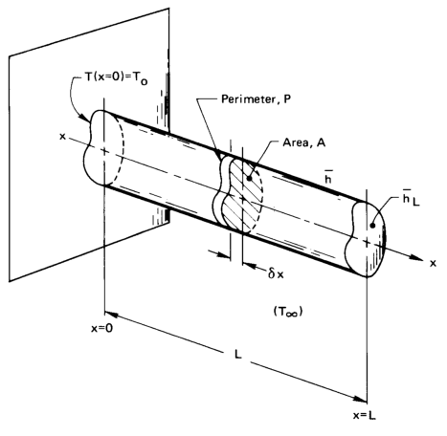
Figure 2.2. Sketch of a one-dimensional fin (Source: Lienhard, 2015)
$kA\frac{d^{2}T}{dx^{2}}dx=\overline{h}\left(Pδx\right)\left(T-T_{∞}\right)$ (2.2)
The equation above can be simplified and re-written as:
$kA\frac{d^{2}T}{dx^{2}}=\overline{h}P\left(T-T_{∞}\right)$ (2.3)
Which is known as the fin equation. The typical boundary condition at the base (x = 0) is $T$ = $T_{b}$, while three forms of b.c.’s can be specified at the fin tip, i.e., specified temperature, specified flux or convection. Before proceeding, we can re-arrange the problem in a dimensional way highlighting that:
$\left(T-T_{∞}\right)=fn[\left(T_{b}-T_{∞}\right),x,L,kA,\overline{h}P]$ (2.4)
Note that the fin’s temperature $T$ can be written in the form of $\left(T-T_{∞}\right)$ because $T_{∞}$ is the lower limit. On the other hand, the dependence between $T$ and $T_{b}$ highlighted by the typical b.c. can be expressed with regard to the temperature difference $\left(T_{b}-T_{∞}\right)$ as well. Also, we have written $kA$ and $\overline{h}P$ as singles variables without considering singularly $A$ and $P$. This is due to the Biot conditions that permits to avoid geometric details about the cross section of the tip: in this way there is no reason to maintain variables that describe the geometry in transversal direction. Thus, we have 6 variables in K, m and W. This gives three pi-groups:
$\frac{T-T_{∞}}{T_{b}-T_{∞}}=fn\left(\frac{x}{L},\frac{\overline{h}PL^{2}}{kA}\right)$ (2.5)
We can re-write the fin equation, renaming $Θ=\frac{T-T_{∞}}{T_{0}-T_{∞}}$, $\overline{x}=x/L$, and $mL=\sqrt{\overline{h}PL^{2}/kA}$ like fin literature suggests:
$\frac{d^{2}Θ}{d{\overline{x}}^{2}}={(mL)}^{2}Θ$ (2.6)
Which is a second order ordinary differential equation, whose general solution is:
$Θ=C_{1}e^{mL\overline{x}}+C_{2}e^{-mL\overline{x}}$ (2.7)
The constants $C_{1}$ and $C_{2}$ can be determined by means of the specified b.c.’s. As already highlighted, a first b.c. is defined by the constant temperature $T_{b}$ at x = 0. In dimensional form it becomes:
$Θ_{\overline{x}=0}=1$ (2.8)
A second b.c. can be defined according to the physical conditions at x = $L$, i.e. $\overline{x}$ = 1. At this regard, two general scenarios are below discussed.
One-dimensional fin with the tip insulated (adiabatic tip)
A b.c. of the second kind can be written as:
${\left.\frac{dΘ}{d\overline{x}}\right|}_{\overline{x}=1}=0$ (2.9)
Substituting Eq.(2.7) into Eq.(2.8) and Eq.(2.9) we get:
$C_{1}+C_{2}=1$ and $C_{1}e^{mL}+C_{2}e^{-mL}=0$ (2.10)
Therefore:
$C_{1}=\frac{e^{-mL}}{e^{mL}+e^{-mL}}$ and $C_{2}=\frac{e^{-mL}}{e^{mL}+e^{-mL}}$ (2.11)
Generally $C_{1}$, $C_{2}$ and consequently $Θ$ are expressed in a simple form using hyperbolic functions:
$C_{1}=\frac{e^{-mL}}{2\cosh{mL}}$ and $C_{2}=1-\frac{e^{-mL}}{2\cosh{mL}}$
Therefore, Eq.(2.7) becomes:
$Θ=\frac{e^{mL(1-\overline{x})}+\left(2\cosh{m}\right)e^{-mL\overline{x}}-e^{-mL(1+\overline{x})}}{2\cosh{m}L}$
which simplifies to:
$Θ=\frac{\cosh{m}(1-\overline{x})}{\cosh{m}}$ (2.12)
To calculate the rate of heat transfer removed from the base we write Fourier’s law at the base of the fin:
$Q=-kA{\left.\frac{d\left(T-T_{∞}\right)}{dx}\right|}_{x=0}$ (2.13)
We multiply Eq.(2.13) by $L/kA\left(T_{b}-T_{∞}\right)$ and thus substitute Eq.(2.12):
$\frac{QL}{kA\left(T_{b}-T_{∞}\right)}=mL\frac{\operatorname{senh}{mL}}{\cosh{m}L}=mL\tanh{m}L$ (2.14)
Finally we obtain:
$\frac{Q}{\sqrt{kA\overline{h}P}\left(T_{b}-T_{∞}\right)}=\tanh{m}L$ (2.15)
Figure 2.3 shows the behavior of such fin. As one can note the heat removal increases with $m$ to a maximum at $mL≃$ 3, which means that no such a fin should be long no more than 2/$mL$ or 3/$mL$: any additional length will have no benefit about heat transfer performance.

Figure 2.3. Temperature distribution and dimensionless heat flux in one-dimensional fin with tip insulated (Adapted from Lienhard, 2015)

One-dimensional fin with the tip uninsulated (diabatic tip)
In this case the approximation of an insulated tip is avoided using a second b.c. of the third kind at the fin tip:
${\left.-k\frac{∂T}{∂x}\right|}_{x=L}=\overline{h}{(T-T_{∞})}_{x=L}$ (2.16)
which, in dimensionless form is:
${\left.\frac{dΘ}{d\overline{x}}\right|}_{\overline{x}=1}=\frac{\overline{h}L}{k}Θ_{\overline{x}=1}=Bi Θ_{\overline{x}=1}$ (2.17)
Substituting Eq.(2.7) into Eq.(2.8) and Eq.(2.17) we get:
$C_{1}+C_{2}=1$ and $-mL(C_{1}e^{mL}-C_{2}e^{-mL})=Bi(C_{1}e^{mL}+C_{2}e^{-mL})$ (2.18)
which result in:
$Θ=\frac{\cosh{mL}\left(1-\overline{x}\right)+\left(Bi/mL\right)\sinh{mL}\left(1-\overline{x}\right)}{\cosh{mL}+\left(Bi/mL\right)\sinh{mL}}$ (2.19)
and the corresponding heat flux equation results as:
$\frac{Q}{\sqrt{kA\overline{h}P}\left(T_{b}-T_{∞}\right)}=\frac{\left(Bi/mL\right)+\tanh{mL}}{1+\left(Bi/mL\right)+\tanh{mL}}$ (2.20)
Note that if $Bi$ $≪$ 1 then Eq.(2.19) approaches Eq.(2.12) and Eq.(2.20) approaches Eq.(2.15); it is hence worth to point out that when $\overline{h}$ is small, as may be in natural convection, $Bi$ is much less than one. In such cases, we can describe the fin behavior considering an equivalent insulated fin. Differently, if $\overline{h}$ is so large that we cannot assume the tip to be insulated, we need to predict it. This is a very challenging issue, as $\overline{h}$ is nearly impossible to predict in most practical cases.

2.4 Measures of fin performance
Two basic measures can be useful to assess the fin performance. The fin efficiency, $η_{f}$, is defined as the ratio between the actual heat transferred by the fin to the heat that would be transferred if the entire fin were at the base temperature $T_{b}$:
$η_{f}=\frac{Q}{Q_{max}}=\frac{Q}{\overline{h}A(T_{b} – T_{∞})}$ (2.21)
With regard to this definition, a very large fin will give a very inefficient fin, while a fin of zero extension will give an efficiency of 100%. Therefore, the efficiency of a fin can provide useful information, even if it is not generally advisable to design toward a particular value of $η_{f}$. However, the fin efficiency is a good parameter for the comparison of fins characterized by the same extension. Fin performance can also be characterized by fin effectiveness, $ε_{f}$, which is the ratio between the actual heat transferred by the fin to the heat transfer rate if there were no fin:
$ε_{f}=\frac{Q}{Q_{w/o, f}}=\frac{Q}{\overline{h}A_{b}(T_{b} – T_{∞})}$ (2.22)
Where $A_{b}$ is the fin cross-sectional area at the base. Generally literature argues that the use of fins is justified only if $ε_{f}≥$ 2. Both fin efficiency and effectiveness are generally useful not for their absolute values, but in characterizing fins with complex shapes. In general, the design of a fin is subjected to several factors, like material cost, geometric constraints, the possible dependence of $\overline{h}$ on temperature and flow velocity, pressure drops caused by the fin itself. These latter aspects will be discussed in Chapter 6. An additional issue in fin design is the problem of specifying the root temperature $T_{b}$. At this regard we can distinguish two general cases: i- the fin protrudes from a wall of the same material, and ii- the fin is in contact with another surface. In the first case there must be a temperature gradient in the neighborhood of the root; on the other hand it is worth to point out that it is hard to measure exactly the temperature at the root and also it may vary in time. In the second case, since two materials are pressed together, some roughness is always present, therefore the plane of contact will include tiny air gaps, and a so-called contact resistance should be taken into account; But, we can bypass this problem considering a plane immediately close to the plane of contact, and assuming for this root a certain temperature. For these reasons, given the purposes of this work, we can assume $T_{b}$ as a given information. For more details about cases i and ii see (Hennecke and Sparrow, 1970) and (Madhusudana, 1996).

References
A. Aziz, Optimum dimensions of extended surfaces operating in a convective environment, Applied Mechanics Reviews 45(5), pp.155-173, 1992.

A. Bejan, A.D. Kraus, Heat transfer Handbook, John Wiley & Sons, Hoboken, 2003.
I. Faraq, J. Reynolds, Heat Transfer, A Theodore Tutorial, Theodore Tutorials, East Williston, NY, 1996.
D.K. Hennecke and E.M. Sparrow, Local heat sink on a convectively cooled surface. Application to temperature measurement error, International Journal of Heat and Mass Transfer, 13, pp.287-304, 1970
A.D. Kraus, Developments in the analysis of Finned arrays, Donald Q. Kern Award Lecture, National Heat Transfer Conference, Baltimore, MD, August 11, 1997, International Journal of Transport Phenomena, 1, pp.141-164, 1999.
A.D. Kraus, Sixty-Five Years of Extended Surface Technology (1922–1987), Applied Mechanics Reviews, 41(9), pp.321-364, 1988.
J. H. Lienhard IV and J. H. Lienhard V, A Heat Transfer Textbook (4th ed.), Cambridge, MA, 2015.
C.V. Madhusudana, Thermal contact conductance, Springer-Verlag, New York, 1996.
L. Theodore, Heat Transfer Applications for the Practicing Engineer, John Wiley & Sons, pp. 672, 2011.
3
T-shaped conductive fins

3.1 Analysis of the “T” assembly
After the general considerations highlighted in Chapter 2, the application considered hereinafter for fins analysis is the cooling of heat generating devices. One of the most appealing characteristic of this kind of application is that one has to face geometry constraints in the limit of decreasing dimensions, in addition to the ordinary fin designing. The T-shaped assembly of fins is sketched in Fig. 3.1. It is composed by three elemental fins: two tributaries of thickness $t_{0}$ and length $L_{0}$ (i.e. one fin of length 2$L_{0}$) and a steam of thickness $t_{1}$ and length $L_{1}$. The configuration is two-dimensional as the third dimension $W$ is supposed to be sufficiently long with respect to $L_{0}$ and $L_{1}$ in order to avoid checkerboard effects. The root of the fin is at temperature $T_{b}$, which is greater than the ambient temperature $T_{∞}$; the heat transfer coefficient $\overline{h}$ defines in this case the cooling of the fin. Like most of the heat sinks used for cooling electronic devices, the T-shaped fin is considered made of aluminum, which is generally preferred to other high conductivity materials thanks to its low cost, low weight and good resistance to corrosion.
The objective of the present analysis is to determine the optimal geometry ($L_{1}/L_{0}$, $t_{1}/t_{0}$) that is characterized by the maximum dissipative capacity, i.e. the maximum (dimensionless) heat flux through the root section. As stated above, the assembly is subjected to size constraints; we introduce the volume constraints namely the total volume (i.e., frontal area) constraint, and the fin material volume constraint:
$A=2L_{0}L_{1}$ and $A_{f}=2L_{0}t_{0}+t_{1}L_{1}$ (3.1)
Recalling the dimension analysis, these constraints can be easily expressed by the fin volume (i.e. frontal area) fraction $φ$, which is a constant parameter generally much smaller than 1:
$φ=A_{f}/A$ (3.2)
In this section we model the heat transfer throughout the fin in the context of pure heat conduction, with heat convection treated as boundary condition. In this kind of problems it is common to refer to a hybrid Biot number through the optimization process, which is the parameter $a$ (< 1):
$a=\sqrt{\frac{2\overline{h}\sqrt{A}}{k}}$ (3.3)
This parameter, which can be considered similar to the fin parameter $m$ discussed in §2.3, links the geometry of the assembly to the heat transfer coefficient $\overline{h}$: fixing $a$, for a given fin frontal area $A$, $\overline{h}$ is determined. In the present context, an air flow-forced convection suggests an order of magnitude of $\overline{h}$ of 10² W/m² K, while the thermal conductivity of aluminum is about 200 W/m K and $\sqrt{A}$ is of the order of 10⁻² m; hence, $a$ is in the order of 10⁻¹.

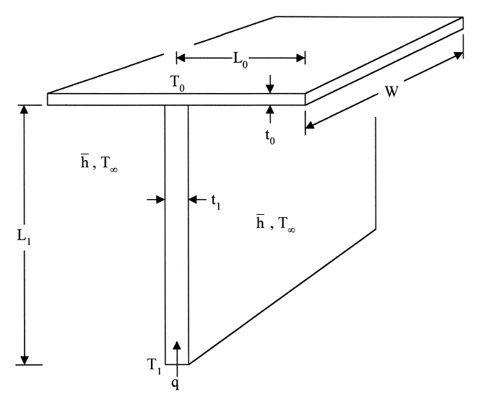
Figure 3.3. T-shaped assembly of plate fins. Adapted from Bejan, 2005

3.2 Literature review
Beside the typical fin configurations described in Chapter 2, the “T” shape has become quite popular in literature. Its appeal it is mainly due to the intrinsic characteristic of miming dendritic and branched structures. The T-shaped fin optimization has been treated in the past by Kraus (Kraus, 1999) and Bejan and Almogbel (Bejan and Almogbel, 2000), in the context of pure heat conduction in steady state. The assembly optimized by Kraus was characterized by $k$ = 200 W/m K, $\overline{h}$ = 60 W/m² K and geometric ratios for the fin that required a frontal area $A$ = 32.4 cm² and $φ$ = 0.086 and gave as results the optimized ratios $L_{1}/L_{0}$ = 0.97 and $t_{1}/t_{0}$ = 5.02. The same settings were adopted by Bejan and Almogbel, who obtained, by means of the Constructal method (Bejan, 1997), a heat flux through the root section 29% higher than Kraus optimized assembly, with geometry ratios equal to $L_{1}/L_{0}$ = 0.28 and $t_{1}/t_{0}$ = 4.69. Note that in the constructal case the tributaries are considerably longer. A finite element analysis in 2D based on the same procedure followed for the following numerical simulations has shown numerical results in total accordance with those reported by Bejan and Almogbel.

3.3 Numerical modelling of T-shaped fins
In this section we need to refer to some essential features of the Heat Transfer Module, the package of COMSOL Multiphysics used for the numeric analysis that includes customized physics interfaces optimized for the analysis of heat transfer. In particular, we refer to the Heat transfer in Solids (hs) physics interface, by means of which the T-shaped assembly has been studied. In a 2D steady-state framework the heat diffusion equation implemented by the hs interface leads to:
$\frac{d^{2}T}{dx^{2}}+\frac{d^{2}T}{dy^{2}}=0$ (3.4)
Note that the only one dependent variables is the temperature $T$. To express a well-posed problem we recall the two b.c.’s, which are a b.c. of the first kind ($T_{b}$ at the root of the fin) and a b.c. of the third kind that is the convective heat transfer at the assembly external surface. In COMSOL these b.c.’s are called, respectively, specified temperature and specified heat flux. Figure 3.2 shows the hs physics frame. Note that only half of the T assembly is considered; indeed many of the numerical problems can take advantage of symmetry so that about half the equations can be eliminated, with consequent much less computational effort. For these reasons we have used a y-symmetric fin representation in this work. In correspondence of the axis of symmetry an additional b.c. of the second kind has been defined in order to properly model the surface thermal insulation in COMSOL. The dimensionless form of the rate of heat transfer $Q$ entering from the root shown in Eq.(3.5) was determined numerically via COMSOL by solving Eq.(3.4) for the temperature field for a given $φ$ in every assumed configuration ($L_{1}/L_{0}$, $t_{1}/t_{0}$) to see whether $\tilde{q}$ could be maximized by varying the geometric configuration of the T-shaped assembly.
$\tilde{q}=\frac{Q}{k(T_{b}-T_{∞})}$ (3.5)
Note that governing differential equations like Eq.(3.4) is not always efficient, especially in case of multidimensional domains and material interfaces that incorporate various b.c.’s: the requirement of continuity of field variables ($T$ in this case) can be too strong. In similar cases weak formulations are preferred as they reduce the continuity requirements on the approximation functions (polynomials) that
substitute the original ones. After rephrasing the problem in its weak form, using for example the Galerkin method, the second step is the domain discretization, where the weak form is discretized in a finite-dimensional space; software like COMSOL multiphysics can easily do that, dividing the original domain into many sub-domains.
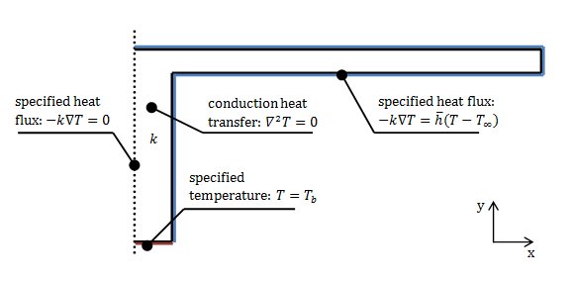
Figure 3.2. Initial conditions and b.c.’s for the numerical T-shaped fin problem
The result is the entire domain covered by a finite number of not-overlapped elements, which is called mesh. Weak forms can give very accurate results with the mesh refinement. Figure 3.3 shows a meshed domain for a sample T-shaped fin. COMSOL permits nine levels of mesh refinement and particular local refinements in addition. Throughout the numerical analysis performed in this work an extra fine element size has been set, i.e. 7th level in the scale from extremely coarse to extremely fine. The appropriate mesh size was determined by successive refinements, passing first from the level fine (182 elements) to finer (200 elements) and finally from finer to extra fine (431 elements), until the criterion $\left|({\tilde{q}}_{max}^{j}-{\tilde{q}}_{max}^{j+1})/{\tilde{q}}_{max}^{j}\right|$ < 2 ∙ 10⁻⁴ was satisfied, where ${\tilde{q}}_{max}^{j+1}$ represents the maximum dimensionless heat flux at $φ$ = 0.15 obtained using the next mesh level available in COMSOL.
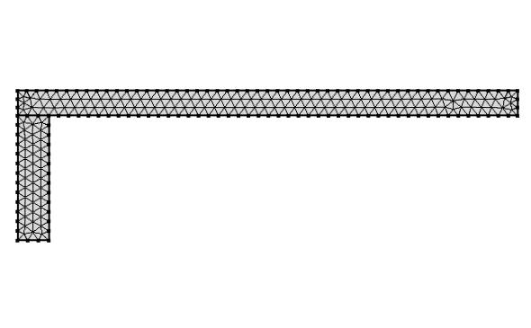
Figure 3.3. A sample mesh refinement for the T-shaped fins modelling
3.4 Method and tests
Several numerical cases have been studied by varying the fin volume fraction $φ$ and the geometric ratios $L_{1}/L_{0}$ and $t_{1}/t_{0}$. Table 3.1 reports the numerical values assigned to $φ$,$L_{1}/L_{0}$ and $t_{1}/t_{0}$, for a total of 396 cases. The latter ratios have been chosen in the vicinity of optimal values obtained in (Bejan and Almogbel, 2000) and each of them has been studied for an assigned volume fraction $φ$; the difference in the series length gap between $t_{1}/t_{0}$ and $L_{1}/L_{0}$ reported in Table 3.1 is due to the higher sensibility characterizing the fin length in comparison to the fin thickness in terms of heat transfer rate. The fin parameter $φ$ is treated in dedicated literature as a constant
Table 3.1. Geometric parameters for T-shaped fins simulations
Parameter | Numerical values
$$φ$$ | 0.10, 0.11, 0.12, 0.13, 0.14, 0.15, 0.16, 0.17, 0.18, 0.19, 0.20
$$L_{1}/L_{0}$$ | 0.15, 0.17, 0.19, 0.21, 0.23, 0.25, 0.27, 0.29, 0.31
$$t_{1}/t_{0}$$ | 3, 4, 5, 6
considerably smaller than 1 because it is strictly related to the amount of conductive material used: it is hence preferable to set $φ$ approaching 0 rather than in the vicinity of 1. The heat diffusion equation (3.4) has been solved for every configuration to find $q$ and see whether $q$ can be maximized by varying the configuration. For each given volume fraction $φ$, the heat transfer problem shows four degrees of freedom which have been limited by fixing $t_{0}$ = 1; consequently, it has been possible to assign a numerical value to $L_{0}$ substituting constraints (3.1) in Eq.(3.2):
$L_{0}=\frac{1}{2φ}\left(\frac{2}{L_{1}/L_{0}}+t_{1}/t_{0}\right)$ (3.6)
Therefore the exact geometry for each T-shaped fin is determined. The heat transfer coefficient $\overline{h}$ is constant for each geometry studied but varies from case to case depending on the particular fin frontal area. Its value is determined rearranging the parameter $a$ (< 1) like suggested in (Lorenzini, Moretti, 2007):
$a=\sqrt{\frac{2\overline{h}\sqrt{A}}{k}}$ → $\overline{h}=\frac{a^{2}k}{2\sqrt{A}}$ (3.7)
Given the size of the assembly in the order of few centimeters, the convective heat transfer $\overline{h}$ in the order of 10² W/m² K, and the thermal conductivity for aluminum of 234 W/m K, $a$ was imposed equal to 0.2. With regard to the chosen value for the thermal conductivity, note that ex-post tests implying different values for $k$ showed how within the range 200$÷$237 W/m K the effect on the heat flux variation was extremely low (between 0.01% and 0.03%); small variations in $k$ do not affect the validity of the model. The values assigned to the root temperature and to the air temperature were, respectively, $T_{b}$ = 373.15 K and $T_{∞}$ = 293.15 K. In this study a Biot number equal to 0.02 has been verified, therefore the hypothesis relying the uniformity of the temperature field within the assembly is verified.
3.5 Results and discussion
The results of the simulations regarding the conductive T-shaped fin are shown in Table 3.2. The highest value for the dimensionless heat flux is obtained for $φ$ = 0.20, which is the highest frontal area fraction modeled, $t_{1}/t_{0}$ = 5 and $L_{1}/L_{0}$ = 0.17. A first useful consideration is the positive correlation between $φ$ and $q$: the more solid material is employed within a conductive-dominant heat transfer environment, the more heat flux is high through the root. The trend of the dimensionless heat flux $q$ can be observed in Figure 3.4 in which, for clarity, only the curves employing even values for $φ$ are shown.
About the geometric ratio$t_{1}/t_{0}$, it can be observed that for each $φ$-group (i.e. a set of assembly with constant $φ$) the lowest value for $t_{1}/t_{0}$, which is 3, denotes the lowest thermal performance of the study, while fins characterized by the ratio $t_{1}/t_{0}$ = 4 are considerably more performing than the latter. The dimensionless heat flux $\tilde{q}$ for fins of $t_{1}/t_{0}$ = 6 is generally higher than groups of fins with $t_{1}/t_{0}$ = 4 while fins characterized by the ratio $t_{1}/t_{0}$ = 5 are mostly performing with respect to other ratios $t_{1}/t_{0}$, with five exceptions displayed for lowest values for both $φ$ and $L_{1}/L_{0}$ ($φ$ = 0.10, $L_{1}/L_{0}$ = 0.15, 0.17, 0.19; $φ$ = 0.11, $L_{1}/L_{0}$ = 0.15, 0.17; $φ$ = 0.12, $L_{1}/L_{0}$ = 0.15). However, these geometries are not the most performing ones for assigned $φ$ equal to 0.10, 0.11 and 0.12. Another point deals with the other geometric ratio $L_{1}/L_{0}$: as $φ$ increases, the maximum dimensionless heat flux tends to vary from higher $L_{1}/L_{0}$ values to lower ones, as shown in Fig. 3.4, in which the curves switch their maximum from the right/bottom to left/top region of the figure. Such tendency highlights that the most performing assemblies in case of less high conductive material used are those whose wetted surface is more extended. In general, the most performing fins at low $φ$, which means low high-conductive material used, are those characterized by a more extended wetted surface, while as $φ$ increases, then the wetted surface tends to
reduce (Fig. 3.5). Numerically, as Eq.(3.7) proves, the less wetted surface is counterbalanced by the increase of the convective heat transfer $\overline{h}$ (in the current 2-D framework, the characteristic length $\sqrt{A}$ and the fin perimeter $P$ show the same trend varying the geometry). Figure 3.6 shows the inverse trend between the characteristic length and the heat transfer coefficient. Note that, for each value of $φ$, the maximum

Table 3.2. Dimensionless heat flux for T-shaped assemblies of fins.
Parameters
$$φ$$ | $$t_{1}/t_{0}$$ | $$L_{1}/L_{0}$$
$$φ$$ | $$t_{1}/t_{0}$$ | 0.15 | 0.17 | 0.19 | 0.21 | 0.23 | 0.25 | 0.27 | 0.29 | 0.31
0.10
 | 3 | 0.05647 | 0.05719 | 0.05774 | 0.05813 | 0.05838 | 0.05854 | 0.05864 | 0.05865 | 0.05863
 | 4 | 0.05788 | 0.05856 | 0.05908 | 0.05942 | 0.05964 | 0.05977 | 0.05982 | 0.05980 | 0.05976
 | 5 | 0.05840 | 0.05907 | 0.05950 | 0.05982 | 0.06003 | 0.06010 | 0.06014 | 0.06009 | 0.06002
 | 6 | 0.05850 | 0.05910 | 0.05953 | 0.05977 | 0.05993 | 0.06003 | 0.06001 | 0.05996 | 0.05988
0.11
 | 3 | 0.05918 | 0.05989 | 0.06041 | 0.06075 | 0.06097 | 0.06109 | 0.06113 | 0.06111 | 0.06102
 | 4 | 0.06054 | 0.06123 | 0.06172 | 0.06202 | 0.06220 | 0.06228 | 0.06228 | 0.06223 | 0.06212
 | 5 | 0.06105 | 0.06170 | 0.06213 | 0.06239 | 0.06253 | 0.06257 | 0.06257 | 0.06248 | 0.06234
 | 6 | 0.06115 | 0.06172 | 0.06210 | 0.06233 | 0.06241 | 0.06243 | 0.06239 | 0.06231 | 0.06220
0.12
 | 3 | 0.06174 | 0.06241 | 0.06288 | 0.06320 | 0.06336 | 0.06345 | 0.06341 | 0.06334 | 0.06324
 | 4 | 0.06308 | 0.06375 | 0.06417 | 0.06443 | 0.06455 | 0.06460 | 0.06454 | 0.06444 | 0.06428
 | 5 | 0.06358 | 0.06418 | 0.06457 | 0.06479 | 0.06488 | 0.06488 | 0.06480 | 0.06467 | 0.06451
 | 6 | 0.06361 | 0.06415 | 0.06451 | 0.06468 | 0.06472 | 0.06471 | 0.06463 | 0.06446 | 0.06428
0.13
 | 3 | 0.06415 | 0.06478 | 0.06523 | 0.06547 | 0.06561 | 0.06561 | 0.06555 | 0.06543 | 0.06527
 | 4 | 0.06548 | 0.06611 | 0.06647 | 0.06669 | 0.06676 | 0.06673 | 0.06664 | 0.06648 | 0.06629
 | 5 | 0.06594 | 0.06651 | 0.06686 | 0.06699 | 0.06705 | 0.06700 | 0.06687 | 0.06667 | 0.06647
 | 6 | 0.06597 | 0.06648 | 0.06676 | 0.06688 | 0.06688 | 0.06681 | 0.06667 | 0.06647 | 0.06624
0.14
 | 3 | 0.06644 | 0.06705 | 0.06743 | 0.06763 | 0.06769 | 0.06764 | 0.06753 | 0.06736 | 0.06714
 | 4 | 0.06776 | 0.06832 | 0.06865 | 0.06880 | 0.06881 | 0.06874 | 0.06858 | 0.06838 | 0.06813
 | 5 | 0.06820 | 0.06873 | 0.06899 | 0.06909 | 0.06908 | 0.06897 | 0.06879 | 0.06855 | 0.06828
 | 6 | 0.06820 | 0.06864 | 0.06888 | 0.06894 | 0.06892 | 0.06878 | 0.06856 | 0.06820 | 0.06805
0.15
 | 3 | 0.06859 | 0.06917 | 0.06948 | 0.06964 | 0.06966 | 0.06955 | 0.06938 | 0.06916 | 0.06890
 | 4 | 0.06991 | 0.07042 | 0.07070 | 0.07078 | 0.07074 | 0.07061 | 0.07039 | 0.07015 | 0.06984
 | 5 | 0.07032 | 0.07079 | 0.07101 | 0.07107 | 0.07098 | 0.07081 | 0.07058 | 0.07031 | 0.06996
 | 6 | 0.07032 | 0.07071 | 0.07089 | 0.07088 | 0.07080 | 0.07058 | 0.07033 | 0.07005 | 0.06971
0.16
 | 3 | 0.07064 | 0.07118 | 0.07144 | 0.07153 | 0.07148 | 0.07133 | 0.07110 | 0.07082 | 0.07051
 | 4 | 0.07195 | 0.07240 | 0.07262 | 0.07266 | 0.07256 | 0.07237 | 0.07208 | 0.07208 | 0.07142
 | 5 | 0.07236 | 0.07276 | 0.07293 | 0.07289 | 0.07277 | 0.07253 | 0.07225 | 0.07190 | 0.07153
 | 6 | 0.07231 | 0.07265 | 0.07278 | 0.07275 | 0.07256 | 0.07230 | 0.07201 | 0.07164 | 0.07126
0.17
 | 3 | 0.07260 | 0.07309 | 0.07329 | 0.07332 | 0.07321 | 0.07299 | 0.07271 | 0.07239 | 0.07202
 | 4 | 0.07390 | 0.07429 | 0.07445 | 0.07442 | 0.07426 | 0.07398 | 0.07368 | 0.07330 | 0.07289
 | 5 | 0.07428 | 0.07462 | 0.07473 | 0.07464 | 0.07444 | 0.07415 | 0.07381 | 0.07342 | 0.07298
 | 6 | 0.07424 | 0.07452 | 0.07458 | 0.07446 | 0.07422 | 0.07392 | 0.07355 | 0.07314 | 0.07272
0.18
 | 3 | 0.07447 | 0.07488 | 0.07502 | 0.07500 | 0.07483 | 0.07457 | 0.07423 | 0.07385 | 0.07344
 | 4 | 0.07574 | 0.07607 | 0.07618 | 0.07608 | 0.07585 | 0.07553 | 0.07517 | 0.07473 | 0.07427
 | 5 | 0.07611 | 0.07641 | 0.07643 | 0.07629 | 0.07602 | 0.07566 | 0.07528 | 0.07481 | 0.07434
 | 6 | 0.07605 | 0.07627 | 0.07627 | 0.07608 | 0.07579 | 0.07543 | 0.07500 | 0.07453 | 0.07405
0.19
 | 3 | 0.07625 | 0.07659 | 0.07670 | 0.07659 | 0.07637 | 0.07605 | 0.07565 | 0.07522 | 0.07475
 | 4 | 0.07750 | 0.07777 | 0.07779 | 0.07764 | 0.07736 | 0.07698 | 0.07655 | 0.07606 | 0.07558
 | 5 | 0.07789 | 0.07809 | 0.07805 | 0.07785 | 0.07751 | 0.07709 | 0.07665 | 0.07614 | 0.07564
 | 6 | 0.07781 | 0.07796 | 0.07787 | 0.07762 | 0.07726 | 0.07682 | 0.07635 | 0.07585 | 0.07532
0.20
 | 3 | 0.07796 | 0.07824 | 0.07827 | 0.07810 | 0.07782 | 0.07744 | 0.07698 | 0.07651 | 0.07602
 | 4 | 0.07920 | 0.07941 | 0.07935 | 0.07912 | 0.07878 | 0.07833 | 0.07785 | 0.07733 | 0.07678
 | 5 | 0.07955 | 0.07970 | 0.07959 | 0.07930 | 0.07892 | 0.07843 | 0.07794 | 0.07739 | 0.07682
 | 6 | 0.07947 | 0.07955 | 0.07941 | 0.07910 | 0.07866 | 0.07817 | 0.07763 | 0.07706 | 0.07651
value calculated for the heat transfer coefficient exceeds the minimum one of a factor of 1.42. Summarizing, assemblies with geometries characterized by a geometric ratio $t_{1}/t_{0}$ = 5 are preferable in terms of heat removal with respect to the other thickness ratios analyzed. On the other hand, the ratio $L_{1}/L_{0}$ shows strong sensitivity on variation of $φ$: the more performing assemblies exhibit increasing $L_{1}/L_{0}$ ratios as $φ$ decreases. Basing on the above consideration we can figure the following guideline
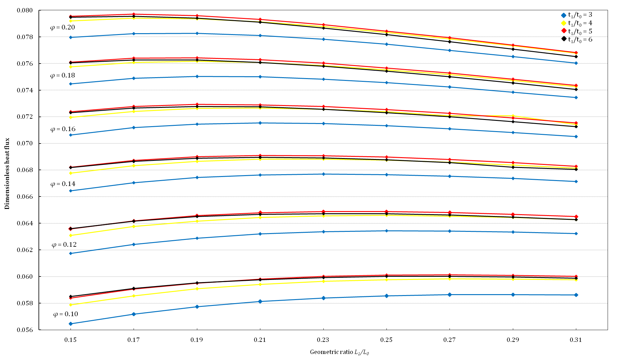
Figure 3.4. Dimensionless heat flux for various T-shaped assemblies of fins.
describing the optimal assemblies depending on the amount of the high conductive material used:
- Low $φ$ → $t_{1}/t_{0}$ = 5 and $L_{1}/L_{0}$ is high
- High $φ$ → $t_{1}/t_{0}$ = 5 and $L_{1}/L_{0}$ is low
As already highlighted, the choose of a particular value for $φ$ is directly connected with the amount of the high conductive material defined for the assembly. Low values for $φ$ are associated to less wide fins, more suitable for spaces where wide heat sinks cannot be used: in this case it is possible to take the advantage of the less material used and consequently to benefit from a cost reduction.
(a) $t_{1}/t_{0}$ = 5; $L_{1}/L_{0}$ = 0.25; $\tilde{q}$ = 0.0626  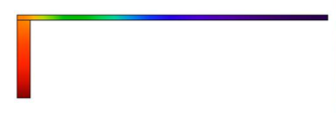 | 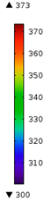
(b) $t_{1}/t_{0}$ = 5; $L_{1}/L_{0}$ = 0.17; $\tilde{q}$ = 0.0797
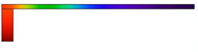
Figure 3.5. Optimal T-shaped fins at $φ$ = 0.11 (a) and $φ$ = 0.20 (b) [K]
So far we have noted how the most performing assemblies of fins were associated to high volume ratios $φ$. However, things can be different in terms of fin efficiency and fin effectiveness. First, it is worth to point out how that in the present context there is no sense to characterize the fin performance according to the fin efficiency $η_{f}$, as the assemblies are characterized all by different surface extensions. However we can use the fin effectiveness $ε_{f}$, since all the assemblies have the same base $A_{b}$. At this regard, the analysis performed has highlighted an high sensitivity of both the
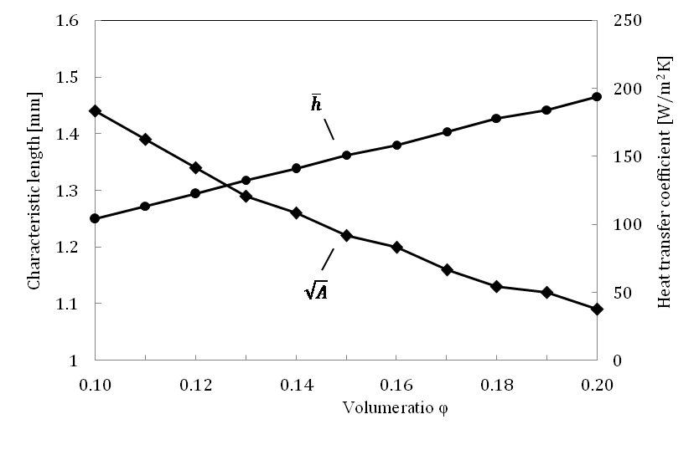
Figure 3.6. The dependence of the heat transfer coefficient on the geometry of the assembly
geometric parameters $φ$ and $t_{1}/t_{0}$ on $ε_{f}$. The results are shown in Figure 3.7: for each value of $φ$ and $t_{1}/t_{0}$ a vertical bar ranges from the maximum value for $ε_{f}$, which correspond to the lowest ratio $L_{1}/L_{0}$, to minimum values for $ε_{f}$ (high ratios $L_{1}/L_{0}$). Each bar is crossed by the mean value of effectiveness for the given $φ$ and $t_{1}/t_{0}$. The difference in $ε_{f}$ among different ratios $L_{1}/L_{0}$ is reduced as $φ$ increases. The most effective fins are those characterized by low values of $φ$, while almost all T-shaped
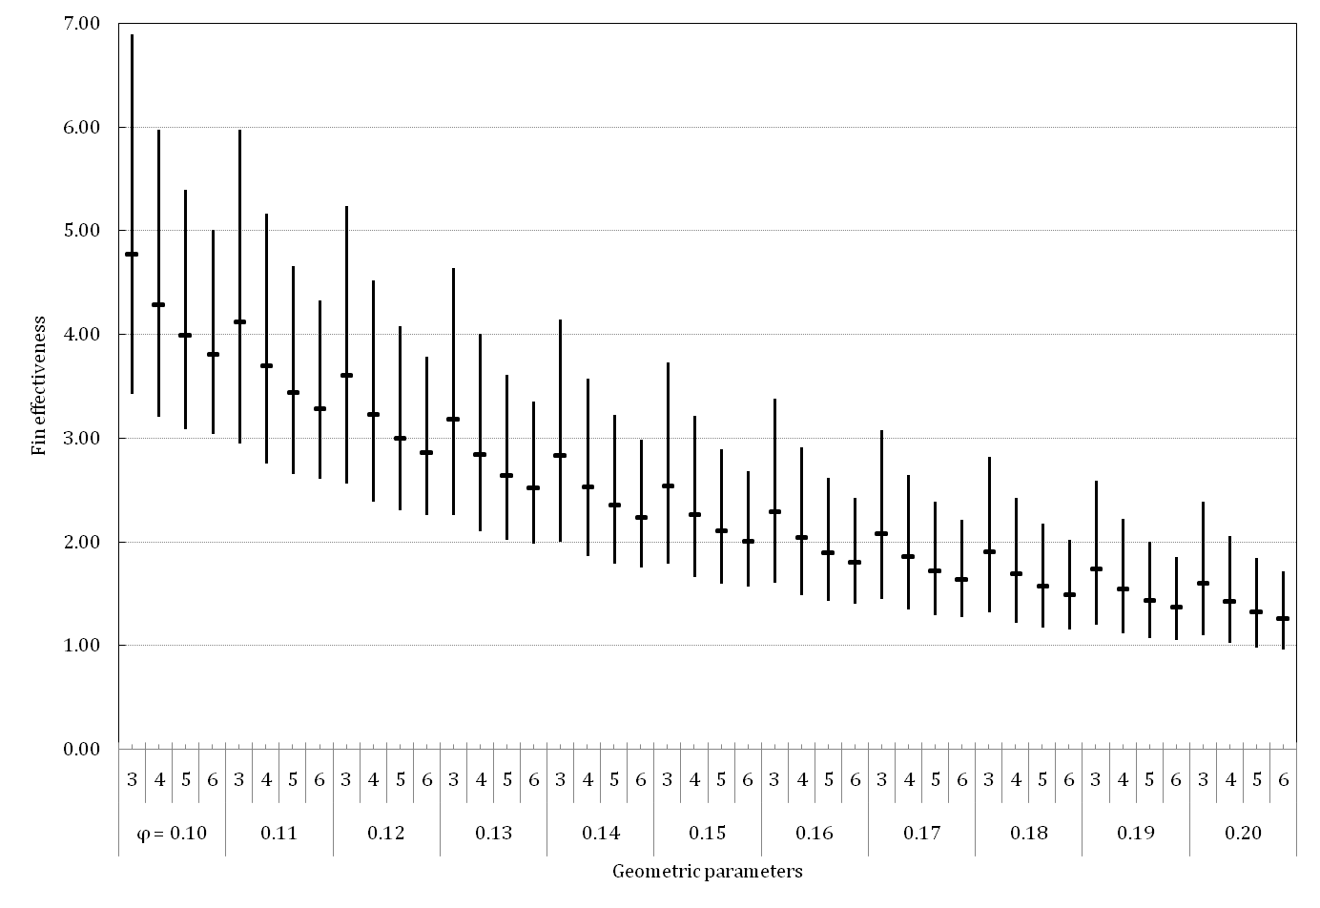
Figure 3.7. Fin effectiveness of T-shaped fins
fins with $φ$ > 0.16 show $ε_{f}≤$ 2, which in literature is considered a lower limit; we can read this circumstance as a signal meaning that for that amount of high conductivity material ($φ$ > 0.16), probably the “T” is not the most suitable shape for a fin, given the amount of the material used and the present convective environment.
We can also define an economic key through which evaluate the assemblies performance: after selecting the optimal assembly for each $φ$, we put them in ascending order according to $φ$; now we can define for contiguous fins the increment of dimensionless heat flux ∆$\tilde{q}$ and, in parallel, the increment of material used ∆$φ$, which is, in this case, fixed and equal to 0.01. We can now calculate ${\tilde{q}}^{'}$ defined as the ratio of the increments of dimensionless heat flux ∆$\tilde{q}$ to the increments ∆$φ$. Table 3.3 shows the results. The values of ${\tilde{q}}^{'}$ are decreasing for $φ$ increasing with the only one exception ($φ$ = 0.11). According to this point of view the fin characterized by $φ$ = 0.11, $t_{1}/t_{0}$ = 5 and $L_{1}/L_{0}$ = 0.25 better justify the additional increment of the high conductive material.
Table 3.3. Thermal performance of optimal T-shaped assemblies
$$φ$$ | Optimal geometry |  | $$\tilde{q}$$ | $${\tilde{q}}^{'}$$  (∆$\tilde{q}$/∆$φ$) | ${\tilde{q}}_{i}^{'}$ - ${\tilde{q}}_{i-1}^{'}$ | $$ε_{f}$$
$$φ$$ | $$t_{1}/t_{0}$$ | $$L_{1}/L_{0}$$
0.10 | 5 | 0.27 | 0.06014 | 22.3%* | -6.08%** | 3.40
0.11 | 5 | 0.25 | 0.06257 | +0.24% | +1.95%* | 3.09
0.12 | 5 | 0.23 | 0.06488 | +23.1% | -1.14% | 2.87
0.13 | 5 | 0.23 | 0.06705 | +21.7% | -1.40% | 2.53
0.14 | 5 | 0.21 | 0.06909 | +20.4% | -1.30% | 2.41
0.15 | 5 | 0.21 | 0.07107 | +19.8% | -0.63% | 2.16
0.16 | 5 | 0.19 | 0.07293 | +18.6% | -1.20% | 2.12
0.17 | 5 | 0.19 | 0.07473 | +17.9% | -0.64% | 1.92
0.18 | 5 | 0.19 | 0.07643 | +17.0% | -0.91% | 1.75
0.19 | 5 | 0.17 | 0.07809 | +16.6% | -0.42% | 1.77
0.20 | 5 | 0.17 | 0.07970 | +16.1% | -0.51% | 1.63
(values determined using *$φ$ = 0.09 and **$φ$ = 0.08)
Also, with reference to the optimal assemblies in the range 0.10 $≤$ $φ$ $≤$ 0.20 and for $a$ = 0.2, the results are correlated within 1.3% by the law shown in Eq.(3.8).
$\tilde{q}$ = 0.194$φ$ + 0.042 (3.8)
$\tilde{q}$ = 0.894$a^{1.08}$ + $φ^{0.407}$ (3.9)
Note that in the power law shown in Eq.(3.9) also the parameter $a$ is involved, although it can be considered less reliable, within 12% (Bejan and Almogbel, 2000). Also, according to the latter authors, in the range 0.10 $≤$ $φ$ $≤$ 0.20 both optimal ratios $t_{1}/t_{0}$ and $L_{1}/L_{0}$ increase monotonically as $a$ increases; in other words the root of the T-shaped fin becomes larger with respect to the arms and approaches a I-shaped fin. This behavior is far from being unexpected if we recall the definition of $a$ and readapt it as highlighted by Eq. (3.10).
$a^{2}=\frac{1/k}{1/2\overline{h}\sqrt{A}}$ = $\frac{internal resistance}{gross external resistance}$ (3.10)
When $a$ is fixed, if the surface is more extended $\overline{h}$ decreases, as mentioned; this imposition may be seen as a limitation, but it partially helps in facing the problem of using a mean value for the heat transfer coefficient: first, there is no sense to increase $\overline{h}$ with the increase of the bathed surface in a forced convection environment; also, over the exposed surfaces of a T-shaped fin at the edges far off the air flow entry, $\overline{h}$ quickly falls down. Note anyhow that for all the cases computed the maximum increment of the frontal surface $A$ for a given $φ$ was 102.5% to which correspond an decrement of $\overline{h}$ of 29.7%, and, in particular, for a geometric ratio of $t_{1}/t_{0}$ = 5, in which are gathered the most performing fins, the maximum increment of $A$ was 24%, with a corresponding decrement of $\overline{h}$ of 10.2%. Therefore the difference in the $\overline{h}$ variation from case to case was very small and lower than an order of magnitude.

References
Bejan, A., Constructal-theory network of conducting paths for cooling a heat generating volume, Int. J. Heat Mass Transfer 40, pp. 799–816, 1997.
Bejan, A., Almogbel, M., Constructal T-shaped fins, International Journal of Heat and Mass Transfer, 43, pp. 2101-2115, 2000.
Kraus, A.D., Developments in the analysis of finned arrays, Donald Q. Kern Award Lecture, National Heat Transfer Conference, Baltimore, MD, August 11, 1997, International Journal of Transport Phenomena, 1, pp. 141-164, 1999.
Lorenzini, G., and Moretti, S., A CFD Application to optimize T-Shaped Fins: Comparison to the Constructal Theory’s Results, Transactions ASME, 129, pp. 324-327, 2007.
Heat Transfer Module User’s Guide, October 2014 version, COMSOL 5.0.
4
Y-shaped conductive fins

4.1 Analysis of the “Y” assembly
In this section an investigation on a different assembly of fins that originates from the T-shaped assembly is performed. The analysis conducted in the previous chapter highlighted how some constructs, among all the optimal fins, are characterized by low effectiveness, and, in general, the aim is to find more performing assemblies starting from the initial T shape. The idea concerning the Y-shaped fin is to vary the position of the tributaries with respect to the fixed T-shaped fin. Therefore an additional variable is added: the angle $α$ with the horizontal line, which theoretically may vary from 0° (i.e. the original "T") to 90°. The Y-shaped assembly of fins is sketched in Fig. 4.1. It is still composed by three elemental fins: two tributaries of thickness $t_{0}$ and length $L_{0}$ and a steam of thickness $t_{1}$ and length $L_{1}$. Note the geometry contains a trapezoidal element at the tip of the base fin. Such kind of assembly, initially proposed in (Lorenzini and Rocha, 2006), was chosen in this work thanks to its versatility with respect to variation of $α$: a preliminary analysis on several Y geometries, precisely on the ways through which it is possible to built the assembly joining tributaries and steam, highlighted geometrical bonds in correspondence of particular tributaries inclines; as a consequence, for values of the angle $α$ greater then a certain value the type of geometry should be re-adapted with a consequent loss of continuity of the geometry itself. This point was considered relevant for the aim of this study because the frontal area of the assembly, which varied passing from a kind of directly affects the value of the fin volume fraction $φ$, and the assemblies are evaluated holding $φ$ as a constant.
Generally the Y-shaped assembly can be seen as a T-shaped fin version with an additional degree of freedom. The optimization is always subjected to the total volume (i.e., frontal area) constraint, and the fin material volume constraint, like T-
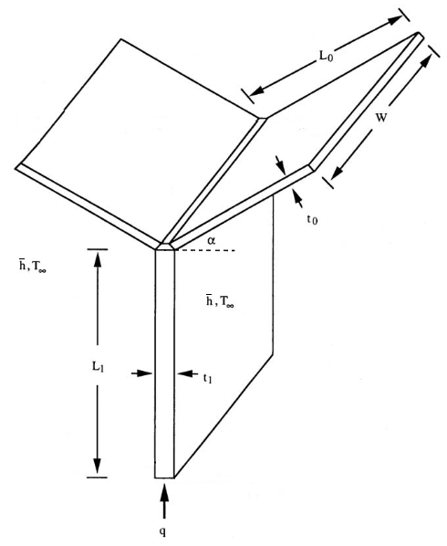
Figure 4.4. Y-shaped assembly of plate fins. Adapted from Lorenzini and Rocha, 2006.
shaped case. They can be expressed by the fin volume fraction $φ$, which is always defined according to Eq.(3.2), while constraints (3.1) become:
$A=\left(L_{1}+L_{0}\sin{α}+t_{0}\cos{α}\right)(2L_{0}\cos{α}+t_{1})$ and
$A_{f}=L_{1}t_{1}+2L_{0}t_{0}+t_{1}t_{0}\cos{α}-{t_{0}}^{2}\sin{α}\cos{α}$ (4.1)
Also in this case the heat transfer throughout the fin is modeled in the context of pure heat conduction with heat convection treated as boundary condition, referring to the parameter $a$ in order to determine the heat transfer coefficient $\overline{h}$ for each modelled geometry of the Y-shaped assembly (Lorenzini and Moretti, 2006):
$a=\sqrt{\frac{2\overline{h}\sqrt{A}}{k}}$ (4.2)
In the ending part of the chapter the adoption of this framework basically consisting on the adoption of a such pre-calculated $\overline{h}$ will be discussed.

4.2 Literature review
In the context of heat transfer applications, the Y shape has been studied in many works. The geometric parameters characterizing this kind of tree-shaped architecture have been obtained in literature by means of Constructal theory (Bejan, 1996; Ledezma et al., 1997) and thermodynamic optimization (Senn and Poulikakos, 2004; Zimparov et al., 2006). Some works deserve a particular mention; Lorenzini and Rocha (Lorenzini and Rocha, 2006) found an optimized assembly via a finite element method for $a$ = 0.10 and a volume ratio (its calculation is slightly different from the one considered in this work) of 0.10 characterized by an optimal ratio $L_{1}/L_{0}$ = 0.10 and an optimal angle in the vicinity of 84°; also, in the range 2 < $t_{1}/t_{0}$ < 10, $t_{1}/t_{0}$ was not a critical degree of freedom.
Another contribute derives from (Sciacovelli et al., 2013); in this work the authors propose a thermodynamic optimization of a Y-shaped fin used to improve the thermal performance of a cylindrical latent heat thermal energy storage, investigating the effect of the variation of both the angle between tributaries (between 0° and 70°) and the length of the steam (between 5 mm and 25 mm) on the energy flux. The optimization results indicate that higher heat flux is achieved by a fin geometry characterized by very long tributaries and an equivalent $α$ = 75°.
Nevertheless it is definitely hard to make a comparison between these studies because of the different geometric settings involved; in particular the parameter $φ$ has proved to lend itself to various geometric interpretations. However, two points can be deduced:
- The optimized Y-shaped assembly is characterized by geometric ratios $L_{1}/L_{0}$ lower in comparison to those of T-shaped fins;
- The value of $α$ is relatively high for the most performing assemblies.

4.3 Numerical modelling of Y-shaped fins
The Y-shaped assembly has been studied by means of the COMSOL interface named Heat transfer in Solids (hs); in a 2D steady-state framework the heat diffusion equation takes the form $∇^{2}T$ = 0, with $T$ the only one dependent variable. The boundary conditions of specified temperature and specified heat flux have been defined like shown in Figure 4.2 where, in addition, to handle the y-symmetric fin representation, an adiabatic surface along the y-axis has been specified. The dimensionless heat flux $\tilde{q}$, already defined in Eq.(3.5) was determined numerically via COMSOL by solving the heat diffusion equation for the temperature field for a given geometry ($L_{1}/L_{0}$, $t_{1}/t_{0}$, $α$) at a specified value of $φ$, to see whether $\tilde{q}$ could be maximized by varying the geometric configuration of the Y-shaped assembly.
The appropriate mesh size was determined by successive refinements. For instance the assembly characterized by $φ$ = 0.15 and $α$ = 49° passed first from the level fine (207 elements) to finer (221 elements) and finally from finer to extra fine (431 elements), until the criterion $\left|({\tilde{q}}_{max}^{j}-{\tilde{q}}_{max}^{j+1})/{\tilde{q}}_{max}^{j}\right|$ < 2 ∙ 10⁻⁴ was satisfied, where ${\tilde{q}}_{max}^{j+1}$ represents the maximum dimensionless heat flux obtained using the next mesh level available in COMSOL.
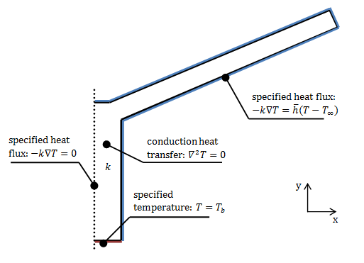
Figure 4.2. Initial conditions and b.c.’s for the numerical Y-shaped fin problem

4.4 Method and tests
Several numerical cases have been studied for different fin geometries by varying the angle $α$ for different values of the frontal area ratio $φ$. With respect to the T-shaped fins modeling, the higher values for the ratio $L_{1}/L_{0}$ (0.27, 0.29, 0.31) are discarded as
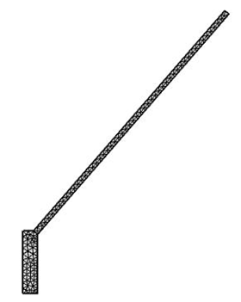
Figure 4.3. A sample mesh refinement for the Y-shaped fins modelling
for the chosen values of $φ$, optimal T-shaped assemblies have $L_{1}/L_{0}$ ≤ 0.25, and, as highlighted in §4.2, optimal Y-shaped assemblies are denoted by low geometric ratios $L_{1}/L_{0}$. So, for a given value of $φ$, the related optimal ratio $L_{1}/L_{0}$ was chosen (see Table 3.2). Also, about the other geometric ratio $t_{1}/t_{0}$, only the value $t_{1}/t_{0}$ = 5 has been chosen, which has proved to be optimal in the T-shaped fins modelling. Table 4.1 reports the numerical values assigned to $φ$,$L_{1}/L_{0}$, $t_{1}/t_{0}$ and, $α$.
Table 4.2. Geometric parameters for Y-shaped fins simulations
Parameter | Numerical values
$L_{1}/L_{0}$ ($φ$) | 0.17 (0.19), 0.19 (0.17), 0.21 (0.15), 0.23 (0.13), 0.25 (0.11)
$$t_{1}/t_{0}$$ | 5
$$α$$ | 1, 7, 13, 19, 25, 31, 37, 43, 49, 55, 61, 67, 73, 79, 85; 88
The degrees of freedom shown in the related heat transfer problem have been limited by fixing $t_{0}$, $t_{1}$ and $L_{1}$, while the value of $L_{0}$ was determined case by case on the basis of the angle $α$ according to the fin constraints (4.1). Furthermore, to satisfy Eq.(4.2) for the varying geometry it has been necessary to rearrange the geometry of the Y-shaped assembly in a dimensional way; hence, Eq.(4.1) and Eq.(4.2) become:
$φ=A_{f}/A={\tilde{L}}_{1}{\tilde{t}}_{1}+2{\tilde{L}}_{0}{\tilde{t}}_{0}+{\tilde{t}}_{1}{\tilde{t}}_{0}\cos{α}-{\tilde{t}}_{0}^{2}\sin{α}\cos{α}$ (4.3)
where the dimensionless parameters are:
${\tilde{t}}_{0}$, ${\tilde{L}}_{0}$, ${\tilde{t}}_{1}$, ${\tilde{L}}_{1}=\frac{t_{0}, L_{0}, t_{1}, L_{1}}{\sqrt{A}}$ (4.4)
The value of the frontal area of the Y-shaped assembly $A$ has been calculated for $α$ = 0°, which denotes a T-shaped assembly. Then, the fixed values for ${\tilde{t}}_{0}$, ${\tilde{t}}_{1}$ and ${\tilde{L}}_{1}$ were determined, and finally ${\tilde{L}}_{0}$ was calculated for each configuration by varying $α$, using Eq.(4.3). Finally, to every geometric parameter was assigned a dimension in order to be computed in COMSOL.

4.5 Results and discussion
The results of the performed simulations are reported in Table 4.2, while Figures 4.4 - 4.8 show the dimensionless heat flux as function of $α$ at different $φ$. It was noted that in the discrete range [1° - 88°] the dimensionless heat flux can be easily approximated with a polynomial of degree greater than 4 with a negligible error. A first useful consideration is that, for every $φ$, $\tilde{q}$ decreases at first ([1° - 43°]),
Table 4.2. Dimensionless heat flux for Y-shaped assemblies
$$α$$ | $$φ$$
$$α$$ | 0.11 | 0.13 | 0.15 | 0.17 | 0.19
1° | 0.0592 | 0.0632 | 0.0636 | 0.0678 | 0.0719
7° | 0.0538 | 0.0570 | 0.0577 | 0.0599 | 0.0644
13° | 0.0504 | 0.0531 | 0.0539 | 0.0551 | 0.0593
19° | 0.0479 | 0.0504 | 0.0512 | 0.0519 | 0.0557
25° | 0.0462 | 0.0484 | 0.0493 | 0.0497 | 0.0531
31° | 0.0450 | 0.0471 | 0.0480 | 0.0482 | 0.0514
37° | 0.0444 | 0.0464 | 0.0473 | 0.0474 | 0.0505
43° | 0.0443 | 0.0462 | 0.0472 | 0.0471 | 0.0502
49° | 0.0446 | 0.0466 | 0.0476 | 0.0474 | 0.0505
55° | 0.0456 | 0.0477 | 0.0486 | 0.0483 | 0.0515
61° | 0.0470 | 0.0492 | 0.0501 | 0.0498 | 0.0531
67° | 0.0492 | 0.0515 | 0.0525 | 0.0521 | 0.0556
73° | 0.0528 | 0.0552 | 0.0565 | 0.0560 | 0.0598
79° | 0.0593 | 0.0618 | 0.0633 | 0.0626 | 0.0672
85° | 0.0690 | 0.0737 | 0.0752 | 0.0744 | 0.0799
88° | 0.0798 | 0.0829 | 0.0842 | 0.0833 | 0.0894

then increases almost asymptotically with the increasing of $α$. A minimum value for$\tilde{q}$ is located in the vicinity of 40° for every $φ$.
As one can note, for each $α$ the most performing assemblies are those characterized by higher $φ$, with a few exceptions, as reported in Table 4.1; an unexpected behavior is highlighted for assemblies at $φ$ = 0.17 as their thermal performance is worse than assemblies at $φ$ = 0.15 for $α$ ≥ 43°.
In general, as $α$ increases the Y assembly heat flux is lower than the T heat flux cross the dimensionless heat flux of the T-shaped fin in the vicinity of 81° for $φ$ = 0.11, at 82° for $φ$ = 0.13, at 83° for $φ$ = 0.15, at 85° for $φ$ = 0.17, and approximately 84° for $φ$ = 0.19. The related values of $\tilde{q}$ for the T-shaped assemblies are, respectively, 0.0626, 0.0671, 0.0711, 0.0747 and 0.0781. Given the present conditions, optimal Y-shape constructs may be recommended only if the value of the angle between arms is relatively high, in general greater than 80°, and this result is in accordance with some literature results reported in §4.2. Figures 4.4 and 4.5 show, respectively, the $\tilde{q}$ trend for Y-shaped fins at $φ$ = 0.11 and at $φ$ = 0.13: they can be considered sufficiently reliable since the results at $α$ = 1° are very close to the related T-shaped dimension-less heat current (the difference are, respectively, -5.4% and -5.8%).
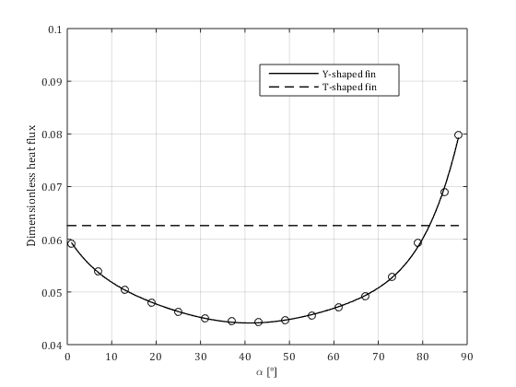
Figure 4.4. Dimensionless heat flux for Y-shaped fins at $φ$ = 0.11
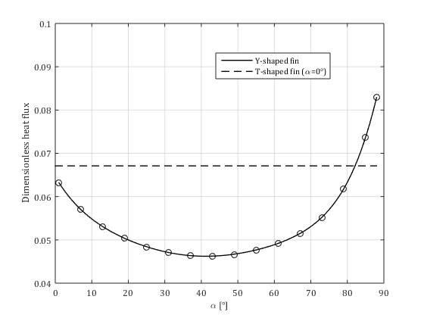
Figure 4.5. Dimensionless heat flux for Y-shaped fins at $φ$ = 0.13
The difference between the heat current for the T-shaped fin and the Y-shaped at $α$ = 1° becomes relevant for $φ$ = 0.15 (-10.5%) as shown in Figure 4.6, and decreases little for $φ$ = 0.17 (-9.3%) as reported in Figure 4.7.
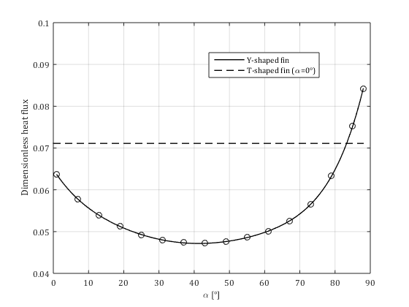
Figure 4.6. Dimensionless heat flux for Y-shaped fins at $φ$ = 0.15
Finally, for $φ$ = 0.19 the two dimensionless heat current substantially differ of 7.9% (Fig. 4.8). At this regard we should remind that the T and Y assemblies geometrically differ, beyond the angle$α$, because of the trapezoidal element at the tip of the base of the Y fin, but such result is definitely exceptional, nevertheless it calls into question the reliability of the performed modelling.
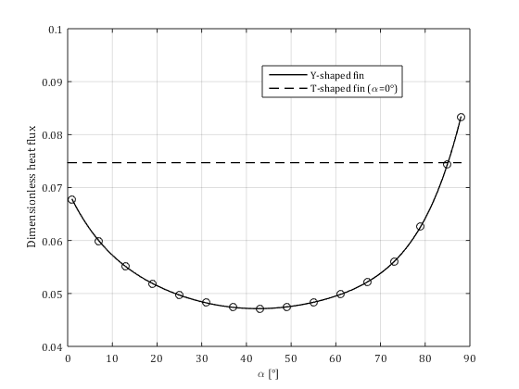
Figure 4.7. Dimensionless heat flux for Y-shaped fins at $φ$ = 0.17
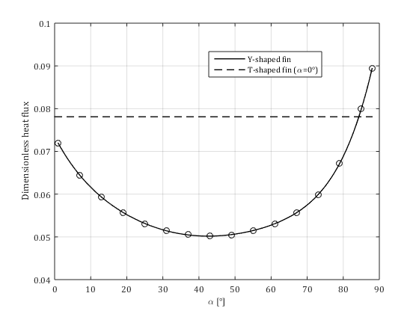
Figure 4.8. Dimensionless heat flux for Y-shaped fins at $φ$ = 0.19
Another point to investigate are the deep changes in dimensionless heat flux following small variation of $α$: firstly, passing from 1° to 7° implicate a decreasing of $\tilde{q}$ of -10.0%, on average, among all $φ$ considered; also, passing from 73° to 79°, from 79° to 85° and finally from 85° to 88° $\tilde{q}$ increases of, respectively, 12.1%, 18.5% and 12.7%. This contrast is due the determination of the heat transfer coefficient $\overline{h}$ on which the conductive model is based (Eq.(4.2)). In the defence of this framework, we should recognized that the surface of the fin varies as $α$ increases because, the Y-shaped assembly changes its shape also in terms of length of the arms $L_{0}$: as already cited, the value of $L_{0}$ was determined case by case on the basis of the angle $α$ according to the fin constraints (4.1). Passing from 1° to 88° causes an increment in $L_{0}$ of 4.0%, 4.5%, 4.9%, 5.2% and 5.8% respectively for fins characterized by $φ$ = 0.11, 0.13, 0.15, 0.17, 0.19. Figure 4.9 shows the increments of $L_{0}$ for each $φ$ considered (note that the variation of $L_{0}$ implies also a consequent variation in the dimensionless ratio $L_{1}/L_{0}$ but, since the variation of $L_{0}$ is very low in absolute terms, the ratio $L_{1}/L_{0}$ is always roughly respected).
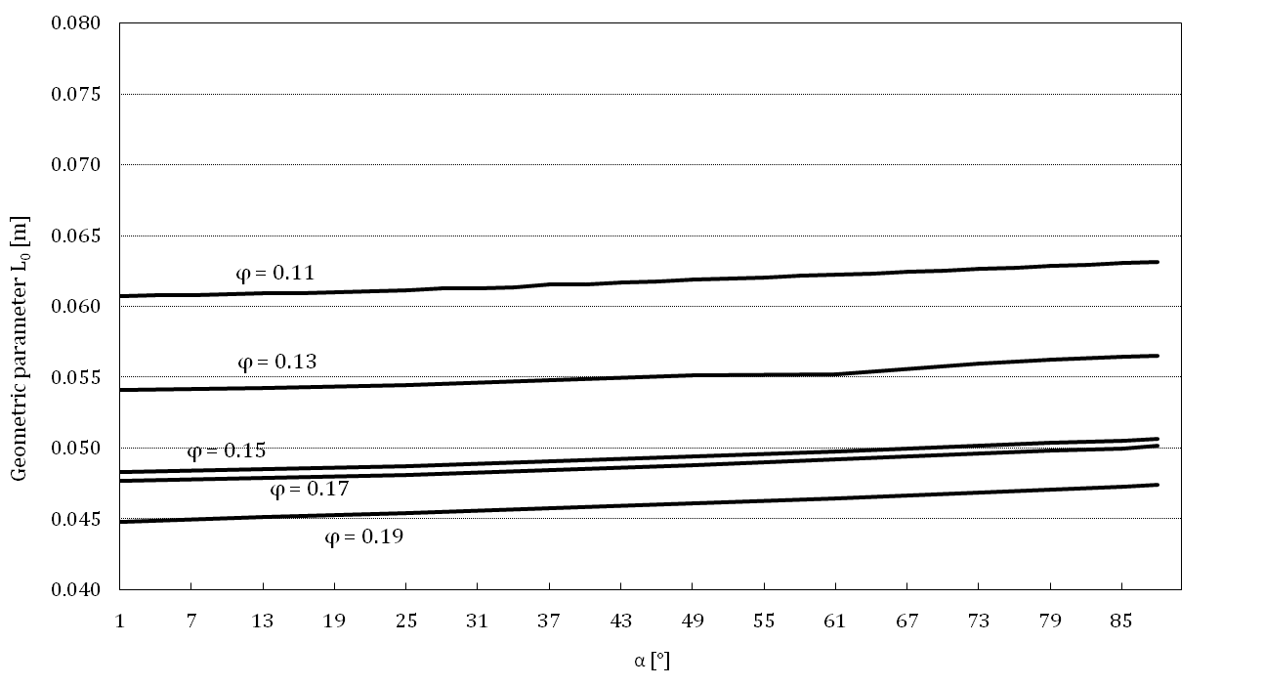
Figure 4.9. Variation of the geometric parameter L₀ with the angle $α$
Coming back to the power performance of the Y-shaped assemblies, it is true that as $α$ increases also the wetted surface augments, however such increment do not justify the asymptotic increasing of $\tilde{q}$ determined by the pre-calculated heat transfer coefficient $\overline{h}$. Table 4.2 reports the value of $\overline{h}$ calculated for angles of 79°, 85° and 88°, for every $φ$. When passing from 79° to 85° it increases of 31.9% on average, and when passing from 85° to 88° the average change reported is +27.5% and it is definitely too much for a difference of just 3 degrees. Furthermore, the values showed for $\overline{h}$ are very high even in absolute terms, considering a limit value for air in forced convection of about 300 W/m² K.

Table 4.3. Heat transfer coefficient for Y-shaped assemblies (W/m² K)
$$α$$ | $$φ$$
$$α$$ | 0.11 | 0.13 | 0.15 | 0.17 | 0.19
79° | 99.3 | 110.8 | 122.7 | 125.6 | 133.2
85° | 132.8 | 147.0 | 161.4 | 165.0 | 174.3
88° | 172.9 | 189.0 | 204.8 | 209.1 | 219.4
Proved that the Y-shaped assembly can be more performing than the T-shaped fins, at the present conditions (the break-even angles are ~81° at $φ$ = 0.11, ~82° at $φ$ = 0.13, ~83° at $φ$ = 0.15, ~85° at $φ$ = 0.17 and ~84° at $φ$ = 0.19), we can compare the two different kind of constructs also in terms of fin effectiveness $ε_{f}$ (note that, like in the T-shaped result analysis, it make no sense to assess the performance using the fin efficiency $η_{f}$, because the assemblies show different surface extensions). As shown in Table 4.4, all the Y-shaped assemblies are considerably more effective than the equivalent T-shaped assemblies.
Table 4.4. Fin effectiveness for Y-shaped and T-shaped assemblies
$$α$$ | $$φ$$
$$α$$ | 0.11 | 0.13 | 0.15 | 0.17 | 0.19
T-shaped fins
0° | 3.1 | 2.5 | 2.2 | 1.9 | 1.8
Y-shaped fins
79° | 5.5 | 4.5 | 3.7 | 3.3 | 3.1
85° | 4.8 | 4.0 | 3.3 | 2.9 | 2.8
88° | 4.3 | 3.5 | 2.9 | 2.6 | 2.5
In this case the most effective Y-shaped fins are those characterized by low $φ$ and low $α$. The next chapters are dedicated to the study of the Y-shaped assembly in the context of conjugate heat transfer, without handling the convective heat transfer as a b.c. with a pre-determined convective heat transfer. The latter condition seems to be indeed the weak point of the dissertation whereas the pure conduction model for heat transfer has demonstrated to be sufficiently reliable: the Biot number, computed taking $L_{0}$ as characteristic length was always much smaller than 1m not exceeding the range 0.02 ≤ $Bi$ ≤ 0.05. In general, $Bi$ ≈ 0.02 was the most common value, while assemblies characterized by $φ$ = 0.11 and 0.13 show Biot numbers of 0.04 and 0.05 for, respectively, $α$ = 85° and 88°, and fins at $φ$ = 0.15, 0.17 and 0.19 reach $Bi$ = 0.03 and 0.04 for the same angles.
(a) $t_{1}/t_{0}$ = 5; $L_{1}/L_{0}$ = 0.21; $\tilde{q}$ = 0.0565  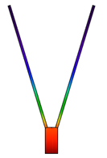 | (b) $t_{1}/t_{0}$ = 5; $L_{1}/L_{0}$ = 0.21; $\tilde{q}$ = 0.0842  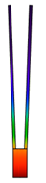
Figure 4.10. Optimal Y-shaped fins at $φ$ = 0.15 for $α$ = 73° (a) and $α$ = 88° (b) [K]

References
Bejan A., Entropy Generation Minimization, CRC Press, Boca Raton, FL, 1996.
Lorenzini G., Moretti S., Numerical analysis of heat removal enhancement with extended surfaces, International Journal of Heat and Mass Transfer, 50, pp. 746-755, 2007.
Lorenzini G., Rocha L. A., Constructal Design of Y-Shaped Assembly of Fins, International Journal of Heat and Mass Transfer, 49, pp. 4552-4557, 2006.
Heat Transfer Module User’s Guide, October 2014 version, COMSOL 5.0.
Kraus A.D., Developments in the analysis of finned arrays, Donald Q. Kern Award Lecture, National Heat Transfer Conference, Baltimore, MD, August 11, 1997, International Journal of Transport Phenomena, 1, pp. 141-164, 1999.
Ledezma G. A., Bejan A., Errera, M.R., Constructal Tree Networks for Heat Transfer, Journal of Applied Physics, 82, pp.89-100, 1997.
Sciacovelli A., Guelpa, E., Verda, V., Second Law Optimization of Y-Shaped Fins for the Solidification Process in a PCM Based Storage System, Proc. of Ecos 2013, Guilin, China, July 13-19, 2013.
Senn S. M., Poulikakos D., Laminar Mixing, Heat Transfer and Pressure Drop in Tree-Like Microchannel Nets and their Applications for Thermal Management In Polymer Electrolyte Fuel Cell, Journal of Power Sources, 130, pp.178-191, 2004.
Zimparov V. D., da Silva A. K., Bejan A., Thermodynamic Optimization of Tree-Shaped Flow Geometries, International Journal of Heat and Mass Transfer, 49, pp. 1619-1630, 2006.

5
Convective heat transfer

5.1 Boundary layers
The most common aim of the analysis about the convective heat transfer is to predict the heat transfer coefficient $h$, or even just $\overline{h}$. As pointed out in Chapter 1, its calculation is a complex task; also in many applications the convective heat transfer is handled as b.c. of the third kind, as performed in Chapter 3 and Chapter 4. In this section we will try to assess how much heat a fluid around a body can add or remove. To give a detailed evaluation of the convective heat transfer process it is necessary to explain the development of the flow field in the vicinity of the body surface.
Momentum boundary layer
A boundary layer (b.l.) is a region of variable velocity built up the body and the free fluid stream. The b.l. is characterized by a certain thickness, $δ$, defined as the distance from the wall at which the flow velocity approaches $u_{∞}$, as shown in Figure 5.1.
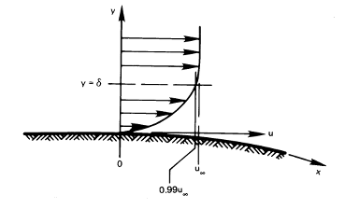
Figure 5.1. A momentum boundary layer (Source: Lienhard, 2015)
The b.l. thickness $δ$ depends on the fluid velocity $u_{∞}$, the fluid density $ρ$ (kg/m³), the dynamic viscosity$μ$ (kg/m s), and the length $x$ along the surface. We can hence define two pi-groups and write the following functional:
$\frac{δ}{x}=fn\left(\frac{ρu_{∞}x}{μ}\right)$ (5.1)
The ratio $\frac{ρu_{∞}x}{μ}$ is called the Reynolds number ($Re$), and it defines the influence that inertial forces have on viscous forces. For a flat surface, if $u_{∞}$ is constant, Eq.(5.1) turns into:
$\frac{δ}{x}=\frac{4.92}{\sqrt{Re}}$ (5.2)
Note that, according to the above equation, if the velocity is great or the viscosity is low, $δ/x$ will be relatively small. On a flat plate, a boundary layer will remain laminar if $Re≤$ 6 ∙ 10⁴, while turbulence is always achieved before $Re≈$ 4 ∙ 10⁶. However, if the surface curves away from the flow, turbulence may be triggered even at much lower values of $Re$. Channel flow is usually considered to change from laminar to turbulent flow at $Re≈$ 2300. Also, the thermal and fluid performance characteristics of the fluid depend on whether the flow is fully developed: the b.l. developed when a cooling fluid enter a channel increases in thickness as the fluid flows through the channel, until the velocity profile become a fully developed profile, in which is possible to distinguish the uniform flow velocity from the stationary fluid at the wall that is the so-called no-slip b.c.
Thermal boundary layer
When a free stream at a temperature $T_{∞}$ adheres a wall at a different temperature $T_{w}$, a thermal boundary layer of thickness $δ_{t}$ is always present (Fig. 5.2).
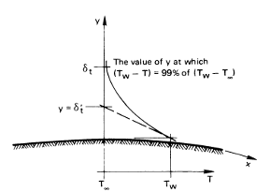
Figure 5.2. A thermal boundary layer over a warm surface (Source: Lienhard, 2015)
We can express the heat removal at the wall using Fourier’s law of conduction as the fluid does not move in the direction of $\vec{q}$:
${\left.-k_{f}\frac{∂T}{∂y}\right|}_{y=0}=h(T_{w}-T_{∞})$ (5.3)
where $k_{f}$ is the conductivity of the fluid. This relation can be re-arranged in the form:
$\frac{∂\left(\frac{T_{w}-T}{T_{w}-T_{∞}}\right)}{∂\left(\frac{y}{L}\right)}=\frac{hL}{k_{f}}$ (5.4)
where $L$ is the characteristic length of the body analyzed and the group $\frac{hL}{k_{f}}$ is called Nusselt number ($Nu)$; its physical significance deduced by Fig. 5.2 is given by:
$Nu=\frac{L}{δ_{t}^{'}}$ (5.5)
which proves that $Nu$ is inversely proportional to the thickness of the thermal b.l. A Nusselt number close to one denotes that both convection and conduction are of similar magnitude, and this characteristic defines a laminar flow. A larger Nusselt number corresponds to a more active convective contribute, with turbulent flow typically in the 100 - 1000 range.
Dimensionless quantities like $Re$ and $Nu$ are very useful in thermal-fluid-dynamical analysis where a lot of variables, besides the temperature, can be involved. To predict the boundary layer flow field it is necessary to solve the equations that express the conservation of energy in the b.l. In the next section we propose a brief overview of these equations.
Another pi-group can be depicted in the analysis of heat transfer in the laminar b.l., that s the Prandtl number, $Pr$.
$Pr=\frac{μc_{p}}{k}≡\frac{ν}{α}$ (5.6)
where $ν$ (m²/s) is the viscous diffusion rate, and $α$ is the thermal diffusion rate. Some reasonable statements were carried out about $Pr$. First, when $Pr$ > 1, $δ$ > $δ_{t}$, and vice-versa; this is true because high viscosity leads to a thick velocity b.l., and high thermal diffusivity give a thick thermal b.l. In general gases are characterized by $Pr$ < 1, and as the complexity of gas molecules increases, $Pr$ approaches 1. In a liquid, the physical mechanism are much more complicated and $Pr$ can be far from one. Also, in case of low $Pr$, $δ_{t}≫$ $δ$, and for practical purposes $u$ = $u_{∞}$ everywhere within the thermal b.l.; the influence of viscosity can be neglected; in this case the determination of $h$ depends on five variables ($x,k,ρc_{p},u_{∞}$) and two pi-group may be defined, which are $Nu$ and ${Re}_{x}Pr$. The latter is called Péclét number, ${Pe}_{x}$, being $x$ the length upon which it is based, and can be seen as:
${Pe}_{x}≡\frac{u_{∞}x}{α}=\frac{ρc_{p}u_{∞}∆T}{k∆T}$ (5.7)
Which a ratio between the heat capacity rate of fluid in the b.l. and axial heat conductance of the b.l.; therefore, if ${Pe}_{x}$ is large the b.l. assumption that $d^{2}T/dx^{2}≪d^{2}T/dy^{2}$ will be valid; otherwise (${Pe}_{x}≪$ 100) it will be violated.

5.2 Conservation laws
The differential equations that describe the heat transfer phenomena when a fluid is considered are the conservation of mass (also called continuity equation), the conservation of momentum (also called Navier-Stokes equations), and the conservation of energy. Eq.(5.6) shows the time-dependent conservation of mass for a closed system:
$\frac{∂ρ}{∂t}+∇\left(ρ\vec{u}\right)=0$ (5.6)
in which $ρ$ is the fluid density and $\vec{u}$ is the fluid velocity. In general the conservation of momentum is written per unit volume as well:
$ρ\left(\vec{f}-\frac{∂\vec{u}}{∂t}\right)+∇\vec{F}=0$ (5.7)
In Eq.(5.7) the vector $\vec{f}$ accounts for mass forces to which the fluid is subjected, and the tensor $\vec{F}$ accounts for shear stresses and pressures. The conservation of energy can be expressed using the following equation:
$ρ\frac{∂e_{tot}}{∂t}-ρ\vec{f}\vec{u}-∇\vec{F}\vec{u} +∇(kT)=0$ (5.8)
where $e_{tot}$ is the sum of specific internal energy and kinetic energy of the particle, while the second and the third term account for the work performed by, respectively, mass forces and stresses; the last term denotes the thermal power that the particle gives to the environment (i.e. Fourier’s Law).

References
A. Bejan, Advanced Engineering Thermodynamics, 3rd ed., John Wiley & Sons, New York, 2006.
R. Bird, W. Stewart, and E. Lightfoot, Transport Phenomena, 2nd ed., John Wiley & Sons, Hoboken, NJ, 2002.
J. Lienhard IV, J. Lienhard V, A Heat Transfer Textbook, 4th ed., Phlogiston Press, Cambridge, MA, 2015.
R.J. Phillips, Microchannel Heat Sinks, The Lincoln Laboratory Journal, 1(1), 1988.

6
Y-shaped convective fins

6.1 Introduction
In Chapter 4 several cases of Y-shaped assemblies, which were defined starting from the T-shaped fins treated in Chapter 3, were studied; the main variable added to the regular assembly was the angle $α$ between the tributaries and the horizontal line. The first useful result was that, for a given volume constraint $φ$, the Y-shaped assembly performed better than an equivalent T-shaped one for values of $α$ greater than a certain value depending on $α$ (in this work it could vary between 80° and 85°). Throughout this work it has become also clear how the performance of any assembly of fins, either T or Y, increased with the augmentation of $φ$ (with just a few exceptions), i.e. with the increasing of high conductive material within the system, which was modeled on pure thermal conduction with the convective heat transfer treated as boundary condition. This latter represented the main limit of the modelling and its limitations emerged in the analysis of the Y-shaped assemblies characterized by very close tributaries. On the other hand, the use of the constant heat transfer coefficient $\overline{h}$ denotes only a particular fluid state and cannot cope with a large variety of practical cases. It is hence necessary to perform a further research about the convective heat transfer to which the assembly is subjected, investigating also the fluid flow characteristics. We have decided to keep on working on the Y-shaped assembly, as it promises a more performing behavior in terms of heat dissipation, according also to the study shown in Chapter 4. In this section we propose a conjugate heat transfer modelling whose application can vary from microchannel heat sinks applications to more large heat sinks with coolant fluid. Nevertheless, in studies concerning electronic cooling it is necessary to handle the whole heat transfer phenomenon, trying to represent the convective heat transfer process as clear as possible, as the need for better cooling methods in microelectronics is becoming nowadays imperative; this is due essentially to reliability reasons: electronic devices produce a very high rate of specific heat, and exceeding in maximum safe operating temperature means strong reduction in lifetime, in addition to lower efficiency. For instance, Mahajan et al. proved that increments of temperature of 10 °C produce a reduction in reliability of the electronic product of half than the original value (Mahajan et al., 2002).

6.2 Literature review
The dedicated literature in extremely wide in the field of electronics cooling. One of the former contributes is due to Tuckerman and Pease who designed and tested a compact, water-cooled integral heat sink for silicon integrated circuits (Tuckerman and Pease, 1981); thus, Knight et al. studied forced convection in heat sinks by means of a dimensional analysis (Knight et al., 1991). The cooling of a compact thermoelectric generator is given in (Rezania et al., 2002), whose results show that it is possible to identify a unique coolant flow rate for a given temperature gradient that optimize the system power balance. Numerical simulations for laminar flows were recently performed by (Senn and Poulikakos, 2004), and recently by (Shafeie et al., 2013), (Mital, 2013) and (Esmaeilnejad et al., 2014). It is worth to say that it has been widely recognized that the bifurcation flow induced by a Y shape can enhance the cooling performance in comparison with more simply geometries, such as the rectangular shape; in particular, the use of a Y-shaped design for assemblies has proved to be quite effective in microchannel heat sinks, basically because it permits the restarting of the boundary layer. Xie et al. (Xie et al., 2014) showed that microchannels subjected to an Y-shaped bifurcation performed better than rectangular microchannels. Lorenzini and Rocha (Lorenzini and Rocha, 2006) and Li et al. (Li et al., 2014) illustrated Y-shaped assemblies to be superior than equivalent rectangular-shaped assemblies by means of the Constructal law. Recently, Xie et al. have studied Y-shaped assemblies integrated with microchannels heat sinks, investigating the effect of the angle between tributaries on the thermal performance (Xie et al., 2015).
Aimed at giving an as much as complete contribution with refer to the works just cited, the analysis performed in this section moves from the results obtained in Chapter 4 regarding the optimal shape of a Y-shaped assembly; also, we will take advantage of some contributes from literature whose settings collide with those in the present analysis. It is important to point out that in this study we have been studying different geometries, and, at the same time, comparison are performed only for fins characterized by a same aspect ratio $φ$. This aspect, surprisingly, did not clearly emerged in the literature analysis, as a large amount of works did not pay too much attention in analyzing and comparing constructs made of by a same amount of material used.

6.3 Convective environment
The architecture of the Y-shaped assembly described in §4.1 will be now briefly reviewed. It is composed by three elemental fins: a steam of thickness $t_{1}$ and length $L_{1}$ and two tributaries of thickness $t_{0}$ and length $L_{0}$ that form an angle $α$ with the horizontal line; also, the geometry contains a trapezoidal element at the tip of the base fin. The assumed configuration is now three-dimensional with the third dimension $W$ = 5$L_{0}$ treated as design parameter.
An external rectangular straight channel consisting of two vertical plates and two horizontal plates is taken as computational domain; its geometry parameters have been determined after suitable tests, as a good trade-off between the choose of little domains (to limit the computational effort) vs. the need to guarantee a good development of the conserving equations. They can be described as follows: the channel width is 1.5 times the fin width: $W_{c}$ = 1.5 ∙ ($t_{1}+L_{0}\cos{α}$); the channel height is 1.2 times the fin height: $H_{c}$ = 1.2 ∙ ($L_{1}+L_{0}\sin{α+t_{0}\cos{α}}$), and the channel length $L_{c}$ is 1.4 times the fin length, indeed the Y-shaped assembly is located at 2/7 from the inlet. This latter parameter is taken as reference from (Xie et al., 2015), as it showed a better thermal performance in comparison with other positioning for the internal fin, in particular 3/7 and 5/7. Note that the channel considered in this work is purely abstract as it is used only to host b.c.'s helping in reducing computations in the domain. Nevertheless, a similar setting can be used for future developments implying other solid heat sinks. The rectangular duct is schematically shown in Fig. 6.1. In this study, where aluminum is taken as reference material for the assembly of fins and air is chosen as cooling medium, thermal conduction transfers heat through the Y-shaped fin, then heat is transferred outside by passing the air through the channel, along the y-axis. The aim is to find the most performing geometry for the Y-shaped assembly.
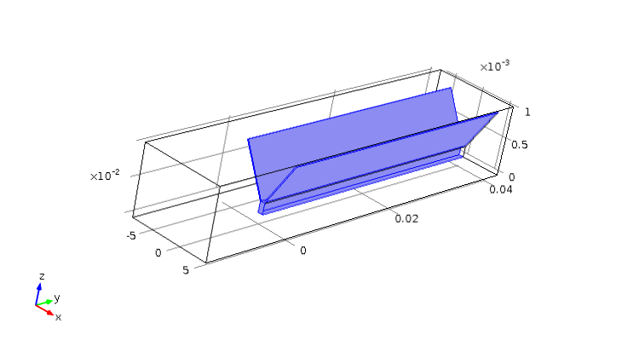
Fig.6.1. Schematic diagram of a single channel with a Y-shaped fin
The geometric parameters of the Y-shaped assembly derive from the results obtained in Chapters 3 and 4. In particular the fins studied in this section are characterized by a geometric ratio $t_{1}/t_{0}$ = 5, which has proved to be the most performing ratio $t_{1}/t_{0}$ throughout all the computations performed. Each Y-shaped assembly, as pointed out in Chapter 4, is material-constrained by the ratio between the total volume of the fin and fin material volume constraint, which simplifies to:
$φ=\frac{V_{f}}{V}=\frac{A_{f}}{A}$ (6.1)
Where
$A=\left(L_{1}+L_{0}\sin{α}+t_{0}\cos{α}\right)(2L_{0}\cos{α}+t_{1})$ and
$A_{f}=L_{1}t_{1}+2L_{0}t_{0}+t_{1}t_{0}\cos{α}-t_{0}^{2}\sin{α}\cos{α}$ (6.2)
To better realize the frontal geometry refer to Fig.4.1. Contrary to $t_{1}/t_{0}$, the ratio $L_{1}/L_{0}$ has shown a relevant dependence on $φ$, as already emerged in the study of T-shaped assembly; also, the introduction of the additional degree of freedom represented by the angle $α$ between tributaries implicates a little variation in $L_{0}$ and hence in the ratio $L_{1}/L_{0}$ too. However, although $L_{0}$ varied as consequence of $α$ variation, the ratio $L_{1}/L_{0}$, was roughly maintained for each $φ$ studied, as observed in §4.5. For the purpose of this study, the condition established by the constraint $φ$ was necessary to satisfy (hard geometric constraint), and for this reason we could accept little variations in $L_{0}$ when the angle $α$ was varied (soft geometric constraint): the aim of this study is to study different geometries comparing them on the basis of a same amount of high-conductive material used. To do so, it has been necessary to rearrange the geometry of the Y-shaped assembly in a dimensional way. So, the constraint (6.1) becomes:
$φ=A_{f}/A={\tilde{L}}_{1}{\tilde{t}}_{1}+2{\tilde{L}}_{0}{\tilde{t}}_{0}+{\tilde{t}}_{1}{\tilde{t}}_{0}\cos{α}-{\tilde{t}}_{0}^{2}\sin{α}\cos{α}$ (6.3)
where the dimensionless parameters are ${\tilde{t}}_{0}$, ${\tilde{L}}_{0}$, ${\tilde{t}}_{1}$, ${\tilde{L}}_{1}=\frac{t_{0}, L_{0}, t_{1}, L_{1}}{\sqrt{A}}$. To satisfy the hard geometric constraint just described, the value of the frontal area $A$ was initially calculated for an T-shaped assembly ($α$ = 0°). Then, ${\tilde{t}}_{0}$ and ${\tilde{t}}_{1}$ where determined using Eq.(6.3) fixing $t_{0}$ = 1 and using $t_{1}/t_{0}$ = 5; $L_{1}$ and $L_{0}$ were determined using the optimal ratio $L_{1}/L_{0}$ resulting from the chosen $φ$ and using initially Eq.(3.6); then T-shaped fin parameters ${\tilde{L}}_{1}$ and ${\tilde{L}}_{0}$ were determined by means of Eq.(6.4); finally, ${\tilde{L}}_{0}$ was calculated for each Y-shaped assembly by varying $α$, using Eq.(6.3).
Table 6.3. Geometric parameters for convective Y-shaped fins simulations
Parameter | Numerical values
$L_{1}/L_{0}$ ($φ$) | 0.17 (0.20), 0.21 (0.15), 0.27 (0.10)
$$t_{1}/t_{0}$$ | 5
$$α$$ | 40°, 60° 80°

6.4 Conjugate heat transfer in laminar flow conditions
Governing equations
The variables to solve in the modelling are velocity, pressure and temperature. In order to simplify the modelling simulation, several assumption are made about the air flow and the materials used. The flow is single-phase and in steady state, and the thermo-physical properties of air and aluminum (considered as isotropic materials) do not vary with temperature, except from the air density. Given a $Pr$ = 0.71 for air, the air viscosity is considered not to vary with the range of temperatures observed in the model. Before starting the simulations the flow regime has been estimated; given the low velocities involved, the thermo-physics characteristics of air and the geometry considered, characterized by a linear dimension of the order of 0.012 m, the flow can be considered laminar ($Re$ < 2000).
For the air domain, the mass conservation reported in Eq.(5.6), becomes stationary as:
$∇\vec{u}=0$ (6.4)
Note that the fluid density $ρ$ is set as constant as the fluid is supposed to be incompressible; this is justified also by the low velocities involved (Mach $≪$ 0.3). The momentum equation takes the following form:
$ρ\left(\vec{u}∙∇\right)\vec{u}+∇p-μ∇^{2}\vec{u}=0$ (6.5)
where $p$ is the fluid pressure and $μ$ is the fluid dynamic viscosity. The terms of Eq.(6.5) correspond to the different forces applied to air that are, respectively, inertial forces, pressure forces and viscous forces. No external force is applied to the fluid, and the effect of gravity force is neglected. The general energy equation used is:
$ρc_{p}\vec{u}∙∇T-k∇^{2}T+Q_{\vec{F}}=0$ (6.6)
where $c_{p}$ is the heat capacity at constant pressure. This equation is developed into two different instances, respectively for the air and solid metal domain. The terms accounts for, respectively, the internal energy of the particles, the heat flux due to conduction, and the stress energy induced by mechanical stresses, including the viscous heating (equal to zero within the aluminum domain).
Boundary conditions and initial settings
The root of the fin is at temperature $T_{b}$ = 373.15 K, which is the highest temperature within the system. The thermal conductivity for aluminum was chosen equal to 234 W/m K, which corresponds to the 1060 aluminum alloy. The air flow enters the system at the temperature $T_{∞}$ = 293.15 K. The general attributes of air and aluminum are reported in Table 6.2.
The boundary conditions were defined as following: for the channel, at the inlet a laminar inflow was imposed characterized by an average velocity and an entrance length imposed equal to 0.06$Re$, while at the outlet a zero value for pressure was imposed. At the external walls a symmetry boundary was added, while the base was defined as no slip and thermal insulated.
Table 6.2. Reference properties for modelled materials
Air | Property name | Value (*initial) | Unit
Dynamic viscosity | $$μ$$ | 1.85e-5* | Pa s
Ratio of specific heats | $$γ$$ | 1.4 | -
Heat capacity at constant pressure | $$c_{p,air}$$ | 1012 | J/kg K
Density | $$ρ_{air}$$ | 1.16* | kg/m³
Thermal conductivity | $$k_{air}$$ | 0.026 | W/m K
Aluminum
Heat capacity at constant pressure | $$c_{p,al}$$ | 897 | J/kg K
Density | $$ρ_{al}$$ | 2700 | kg/m³
Thermal conductivity | $$k_{al}$$ | 234 | W/m K

Mesh definition
In general, the mesh was set as free tetrahedral with the two domains containing air and aluminum subjected to different refinement, as they are characterized by different physical contexts. For the fluid-dynamic domain, the mesh was defined according to the thickness of the momentum boundary layer for air as, in case of low $Pr$, $δ≪δ_{t}$. The minimum element size was hence fixed equal to$δ$, while the maximum element size was arbitrarily at 2$δ$. The momentum boundary layer was calculated by means of (Bejan, 1985):
$δ=\frac{L}{\sqrt{Re}}$ (6.7)
Where$Re$ was calculated using the initial values of the air properties (at the channel inlet) and $L$ is the typical length of the channel, i.e. the hydraulic diameter of the channel:
$L=\frac{4A_{c}}{P_{c}}$ (6.8)
being $A_{c}$ the cross-sectional area of the channel and $P_{c}$ the wetted perimeter of the
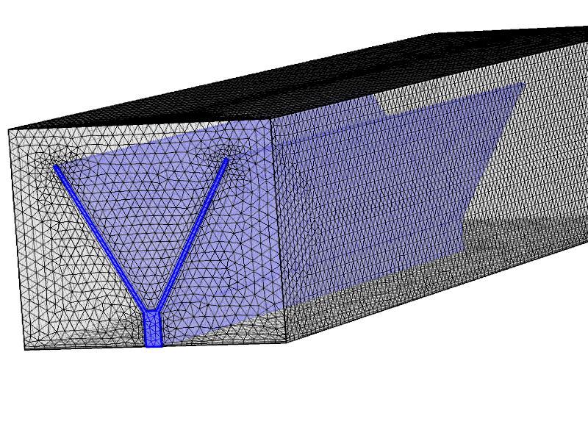
Fig.6.2. A sample mesh refinement for the convective Y-shaped fins modelling
cross section. For the fluid-dynamic domain, the mesh was defined according to the lowest solid thickness of the assembly, represented by the tributary thickness; a maximum element size of the triple was admitted inside the steam far away from the boundaries. Fig.6.2 shows a sample mesh characterized by a minimum element size of 0.268 mm.
Results
In this work we have investigated different kinds of Y-shaped fins characterized by three different aspect ratios $φ$ (0.10, 0.15, 0.20), three values of $α$ (40°, 60°, 80°). Also, two different values of average initial velocity were investigated: 1 m/s and 3 m/s. All the Y-shaped fin instances modeled in laminar flow conditions are described in the following cases. The Reynolds number at the inlet is defined as:
$Re=\frac{ρ_{air}\overline{u}L}{μ}$ (6.9)
where $ρ_{air}$ is the fluid density, $\overline{u}$ is the average velocity at the inlet of the channel, $L$ is the hydraulic diameter and $μ$ is the dynamic viscosity of the fluid. The dimensional heat flux is calculated as:
$\tilde{q}=\frac{Q}{k_{al}W(T_{b}-T_{∞})}$ (6.10)
where $Q$ (W) is the total heat flux through the root of the assembly. The heat transfer coefficient is defined as:
$\overline{h}=\frac{Q}{A_{f}W(T_{b}-T_{∞})}$ (6.11)
being $A_{f}W$ the wetted surface of the fin.
Cases 1-3. Cases 1, 2 and 3 regards the modelling of assembly characterized by an aspect ratio of $φ$ = 0.10 subjected to a laminar inflow at 1 m/s. The results are reported in Table 6.3. The flow regime is completely laminar for every assigned value of $α$, therefore the momentum b.l. is relatively thick (0.429 mm). Case 1 ($α$ = 40°) shows the best thermal performance, and the dimensionless heat flux shows a decreasing trend with the increasing of $α$, although the differences among the different fins are very small: a 4.7% difference in dimensionless heat flux is found when passing from Case 1 to Case 3. Figs. 6.3 and 6.4 show, respectively, the tempe-
Table 6.3. Numerical results for Cases 1-3
Case 1 ($φ$ = 0.10, $α$ = 40°, $\overline{u}$ = 1 m/s)
Laminar flow | $$Re$$ | 538.1 | (-)
Momentum b.l. | $$δ$$ | 4.29E-04 | (m)
Mesh | n. o. e. | 912'774 | (-)
Dim. heat flux | $$\tilde{q}$$ | 0.00342 | (-)
Total heat flux | Q | 2.0813 | (W)
Heat transfer coefficient | $$\overline{h}$$ | 26.579 | (W/m² K)
Case 2 ($φ$ = 0.10, $α$ = 0°, $\overline{u}$ = 1 m/s)
Laminar flow | $$Re$$ | 528.8 | (-)
Momentum b.l. | $$δ$$ | 4.25E-04 | (m)
Mesh | n. o. e. | 893'201 | (-)
Dim. heat flux | $$\tilde{q}$$ | 0.00337 | (-)
Total heat flux | Q | 2.0727 | (W)
Heat transfer coefficient | $$\overline{h}$$ | 26.018 | (W/m² K)
Case 3 ($φ$ = 0.10, $α$ = 80°, $\overline{u}$ = 1 m/s)
Laminar flow | $$Re$$ | 323.2 | (-)
Momentum b.l. | $$δ$$ | 3.33E-04 | (m)
Mesh | n. o. e. | 695'715 | (-)
Dim. heat flux | $$\tilde{q}$$ | 0.00325 | (-)
Total heat flux | Q | 2.0289 | (W)
Heat transfer coefficient | $$\overline{h}$$ | 25.011 | (W/m² K)

Case 1 | Case 2 | Case 3
- First fin cross section: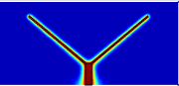 | 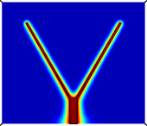 | 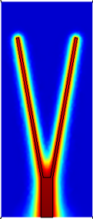 | 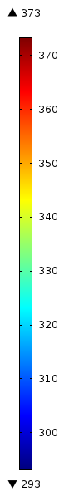
- Middle fin cross section: 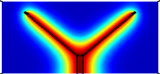 | 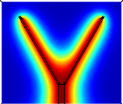 | 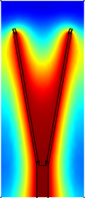
- Ending fin cross section: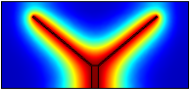 | 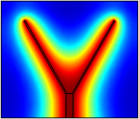 | 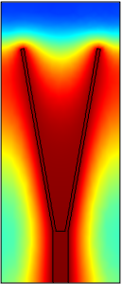
Fig.6.3. Domain temperature for Cases 1-3 [K]
-rature field and the velocity field for all domains in cross-sectional section of the channel. The flow velocity, which is zero at the bottom wall, increases along the z-direction according to a laminar inflow; the no slip condition is satisfied also for the external surface of the Y-shaped assembly, indeed the velocity increases, before reaching the undisturbed condition at the upper wall, also along the x-direction. Case 3 is characterized at the same time by higher temperatures and a quite extended area characterized by null velocities at the beginning of the assembly bifurcation. This phenomenon, due to the high vicinity of no slip walls and probably to the relatively low air velocity, results in an unsatisfying thermal dissipation. On the other hand, Case 1 represent a better trade-off in terms of heat dissipation as it is denoted by a shape more suitable for a low velocity air cooling.
Case 1 | Case 2 | Case 3
- First fin cross section: 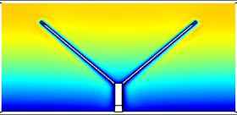 | 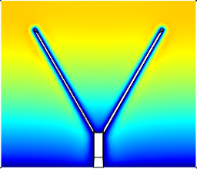 | 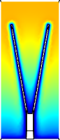 | 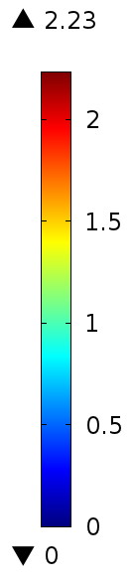
- Middle fin cross section: 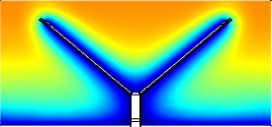 | 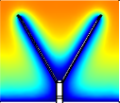 | 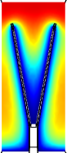
- Ending fin cross section: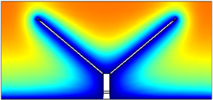 | 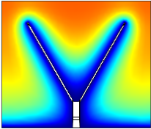 | 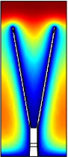
Fig.6.4. Domain velocity for Cases 1-3 [m/s]

Cases 4-6. Cases 4, 5 and 6 regards the modelling of assembly characterized by an aspect ratio of $φ$ = 0.10 subjected now to a laminar inflow at 3 m/s. The results are reported in Table 6.4. The flow regime is laminar for every assigned value of $α$. With respect to Cases 1-3, given a higher velocity at the inlet, these experiments are characterized by a thinner b.l.; as a consequence, a mesh characterized by a higher number of elements (about +30%) has been obtained. The highest velocity permits in general to obtain better dissipative effects. Both the temperature and the velocity fields are now more developed (Figs. 6.5 and 6.6). Case 5 ($α$ = 60°) is characterized by the lowest $\tilde{q}$, while Case 6 ($α$ = 80°) shows the best thermal performance (+4.2%): in this case, the higher velocity permits to overcome the no-slip condition at the fin bifurcation.
Table 6.4. Numerical results for Cases 4-6
Case 4 ($φ$ = 0.10, $α$ = 40°, $\overline{u}$ = 3 m/s)
Laminar flow | $$Re$$ | 1614.3 | (-)
Momentum b.l. | $$δ$$ | 2.48E-04 | (m)
Mesh | n. o. e. | 1'236'114 | (-)
Dim. heat flux | $$\tilde{q}$$ | 0.00626 | (-)
Total heat flux | Q | 3.8118 | (W)
Heat transfer coefficient | $$\overline{h}$$ | 48.68 | (W/m² K)
Case 5 ($φ$ = 0.10, $α$ = 60°, $\overline{u}$ = 3 m/s)
Laminar flow | $$Re$$ | 1586.3 | (-)
Momentum b.l. | $$δ$$ | 2.46E-04 | (m)
Mesh | n. o. e. | 1'147'791 | (-)
Dim. heat flux | $$\tilde{q}$$ | 0.00618 | (-)
Total heat flux | Q | 3.799 | (W)
Heat transfer coefficient | $$\overline{h}$$ | 47.69 | (W/m² K)
Case 6 ($φ$ = 0.10, $α$ = 80°, $\overline{u}$ = 3 m/s)
Laminar flow | $$Re$$ | 969.5 | (-)
Momentum b.l. | $$δ$$ | 1.92E-04 | (m)
Mesh | n. o. e. | 975'572 | (-)
Dim. heat flux | $$\tilde{q}$$ | 0.00644 | (-)
Total heat flux | Q | 3.799 | (W)
Heat transfer coefficient | $$\overline{h}$$ | 49.35 | (W/m² K)

Case 4 | Case 5 | Case 6
- First fin cross section: 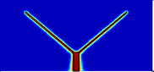 | 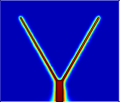 | 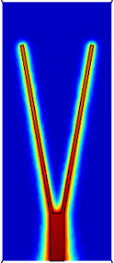
- Middle fin cross section: 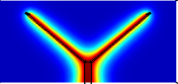 | 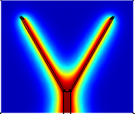 | 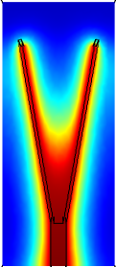
- Ending fin cross section: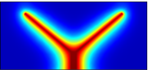 | 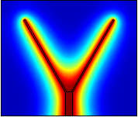 | 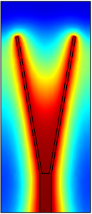
Fig. 6.5. Domain temperature for Cases 4-6 [K]

Case 4 | Case 5 | Case 6
- First fin cross section: 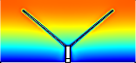 | 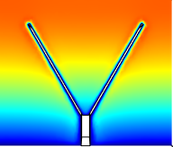 | 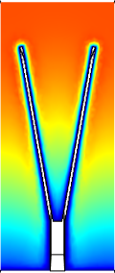 | 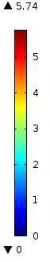
- Middle fin cross section: 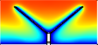 | 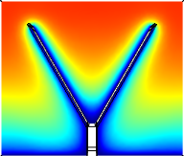 | 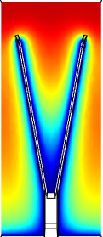
- Ending fin cross section: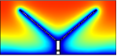 | 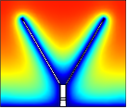 | 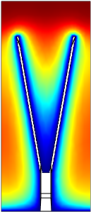
Fig. 6.6. Domain velocity for Cases 4-6 [m/s]
Cases 7-9. Cases 7, 8 and 9 regards the modelling of assembly characterized by an aspect ratio of $φ$ = 0.15 subjected to a laminar inflow at 1 m/s. The results are shown in Table 6.5. Like Cases 1-3, given the low air velocity, the flow regime is strictly laminar and the momentum b.l. is relatively thick; consequently, the mesh was characterized by an affordable number elements. Case 7 ($α$ = 40°) was characterized by the best thermal performance with a dimensionless heat flux equal to 0.00377, while cases 8 ($α$ = 60°) and 9 ($α$ = 80°) are characterized by almost equal performances. These results are substantially aligned with those corresponding to Cases 1-3; the main difference is played by a higher amount of conductive material that allows an enhancement of the heat transfer from the fin to the air. The thermal and velocity fields for Cases 7-9 are shown respectively in Fig. 6.7 and 6.8. The flow velocity, which is zero at the bottom wall, increases along all directions; Case 9 is denoted by the highest velocity field thanks its extended arms (with respect to Case 3, characterized by the same $α$ = 80°, the fin is slightly wider, therefore a more extended area between tributaries is obtained). Figs. 6.7 shows the temperature field for Cases 7-9, while Fig. 6.8 shows the relative velocity field.
Table 6.5. Numerical results for Cases 7-9
Case 7 ($φ$ = 0.15, $α$ = 40°, $\overline{u}$ = 1 m/s)
Laminar flow | $$Re$$ | 626 | (-)
Momentum b.l. | $$δ$$ | 4.63E-04 | (m)
Mesh | n. o. e. | 688’703 | (-)
Dim. heat flux | $$\tilde{q}$$ | 0.00377 | (-)
Total heat flux | Q | 2.8359 | (W)
Heat transfer coefficient | $$\overline{h}$$ | 24.56 | (W/m² K)
Case 8 ($φ$ = 0.15, $α$ = 60°, $\overline{u}$ = 1 m/s)
Laminar flow | $$Re$$ | 401.3 | (-)
Momentum b.l. | $$δ$$ | 3.71E-04 | (m)
Mesh | n. o. e. | 665’186 | (-)
Dim. heat flux | $$\tilde{q}$$ | 0.00374 | (-)
Total heat flux | Q | 2.8887 | (W)
Heat transfer coefficient | $$\overline{h}$$ | 23.91 | (W/m² K)
Case 9 ($φ$ = 0.15, $α$ = 80°, $\overline{u}$ = 1 m/s)
Laminar flow | $$Re$$ | 631.8 | (-)
Momentum b.l. | $$δ$$ | 4.65E-04 | (m)
Mesh | n. o. e. | 504’938 | (-)
Dim. heat flux | $$\tilde{q}$$ | 0.00374 | (-)
Total heat flux | Q | 2.85 | (W)
Heat transfer coefficient | $$\overline{h}$$ | 24.23 | (W/m² K)

Case 7 | Case 8 | Case 9
- First fin cross section: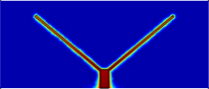 | 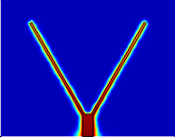 | 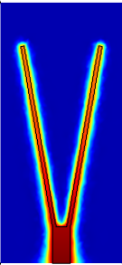
- Middle fin cross section: 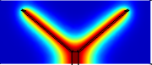 | 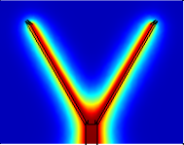 | 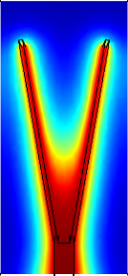
- Ending fin cross section: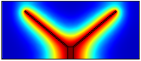 | 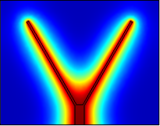 | 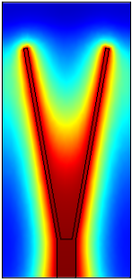
Fig. 6.7. Domain temperature for Cases 7-9 [K]
Case 9 is characterized by a higher temperature field between tributaries in comparison to Cases 7 and 8, and, at the same time, the air velocity approaches a zero value through the fin bifurcation. However, such effects are diminished with respect to Cases 1-3.

Case 7 | Case 8 | Case 9
- First fin cross section: 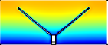 | 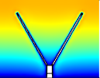 | 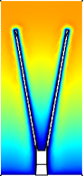 | 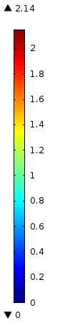
- Middle fin cross section: 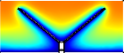 | 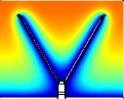 | 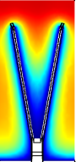
- Ending fin cross section: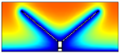 | 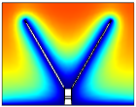 | 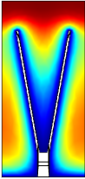
Fig. 6.8. Domain velocity for Cases 7-9 [m/s]
Cases 10-12. Cases 10, 11 and 12 regards the modelling of assembly characterized by an aspect ratio of $φ$ = 0.15 subjected to a laminar inflow at 3 m/s. The modelling results are aligned to those of Cases 4-6 ($φ$ = 0.10), with better thermal performance guaranteed by more high conductive material used; the fin at $α$ = 80° is the most performing, followed by the assembly at $α$ = 40°, then the fin at $α$ = 60°. In particular, when passing from Case 11 to Case 12 $\tilde{q}$ increases of 4.4%.

Table 6.6. Numerical results for Cases 10-12
Case 10 ($φ$ = 0.15, $α$ = 40°, $\overline{u}$ = 3 m/s)
Laminar flow | $$Re$$ | 1877.9 | (-)
Momentum b.l. | $$δ$$ | 2.67E-04 | (m)
Mesh | n. o. e. | 1’243’040 | (-)
Dim. heat flux | $$\tilde{q}$$ | 0.00707 | (-)
Total heat flux | Q | 5.315 | (W)
Heat transfer coefficient | $$\overline{h}$$ | 46.04 | (W/m² K)
Case 11 ($φ$ = 0.15, $α$ = 60°, $\overline{u}$ = 3 m/s)
Laminar flow | $$Re$$ | 1895.5 | (-)
Momentum b.l. | $$δ$$ | 2.68E-04 | (m)
Mesh | n. o. e. | 1’101’901 | (-)
Dim. heat flux | $$\tilde{q}$$ | 0.00701 | (-)
Total heat flux | Q | 5.3394 | (W)
Heat transfer coefficient | $$\overline{h}$$ | 45.40 | (W/m² K)
Case 12 ($φ$ = 0.15, $α$ = 80°, $\overline{u}$ = 3 m/s)
Laminar flow | $$Re$$ | 1203.9 | (-)
Momentum b.l. | $$δ$$ | 2.14E-04 | (m)
Mesh | n. o. e. | 961’900 | (-)
Dim. heat flux | $$\tilde{q}$$ | 0.00732 | (-)
Total heat flux | Q | 5.6133 | (W)
Heat transfer coefficient | $$\overline{h}$$ | 46.79 | (W/m² K)
The higher velocities permit to achieve better dissipative effects in comparison to Cases 7-9, with more developed temperature fields (Fig. 6.9) and especially velocity fields (Fig. 6.10). Case 12 ($α$ = 80°) shows the best thermal performance: like Case 6, also in this case the higher velocity permits to overcome the no-slip condition at the fin bifurcation and to realise a deeper velocity field between the fin arms. Case 10 ($α$ = 40°) is characterized by a dimensionless heat flux that is very close with respect to Case 11 ($α$ = 60°).

Case 10 | Case 11 | Case 12
- First fin cross section: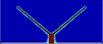 | 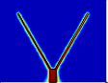 | 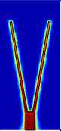
- Middle fin cross section: 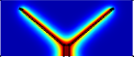 | 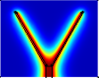 | 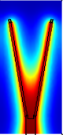
- Ending fin cross section: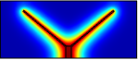 | 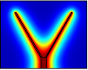 | 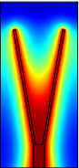
Fig. 6.9. Domain temperature for Cases 10-12 [K]

Case 10 | Case 11 | Case 12
- First fin cross section: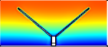 | 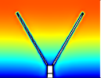 | 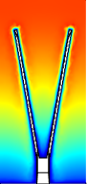 | 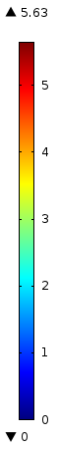
- Middle fin cross section: 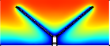 | 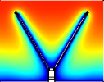 | 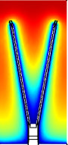
- Ending fin cross section: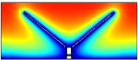 | 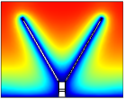 | 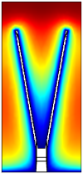
Fig. 6.10. Domain velocity for Cases 10-12 [m/s]
Cases 13-15. Cases 13, 14 and 15 regard the modelling of assemblies characterized by an aspect ratio of $φ$ = 0.20 subjected to a laminar inflow at 1 m/s. Like Cases 1-3 and 7-9, the relative low air velocity permits to realize a strictly laminar flow; hence a relative thick b.l. has been found and an affordable mesh has been applied. The results, shown in Table 6.7, show how the thermal performance are substantially aligned, with very close values for dimensionless heat flux: 0.00407 for Case 15 ($α$ = 80°), 0.00406 for Case 13 ($α$ = 40°), and 0.00404 for Case 14 ($α$ = 60°); in other
Table 6.7. Numerical results for Cases 13-15
Case 13 ($φ$ = 0.20, $α$ = 40°, $\overline{u}$ = 1 m/s)
Laminar flow | $$Re$$ | 673.9 | (-)
Momentum b.l. | $$δ$$ | 4.80E-04 | (m)
Mesh | n. o. e. | 539'029 | (-)
Dim. heat flux | $$\tilde{q}$$ | 0.00406 | (-)
Total heat flux | Q | 3.3797 | (W)
Heat transfer coefficient | $$\overline{h}$$ | 24.16 | (W/m² K)
Case 14 ($φ$ = 0.20, $α$ = 60°, $\overline{u}$ = 1 m/s)
Laminar flow | $$Re$$ | 691.6 | (-)
Momentum b.l. | $$δ$$ | 4.87E-04 | (m)
Mesh | n. o. e. | 513'935 | (-)
Dim. heat flux | $$\tilde{q}$$ | 0.00404 | (-)
Total heat flux | Q | 3.4195 | (W)
Heat transfer coefficient | $$\overline{h}$$ | 23.85 | (W/m² K)
Case 15 ($φ$ = 0.20, $α$ = 80°, $\overline{u}$ = 1 m/s)
Laminar flow | $$Re$$ | 451.7 | (-)
Momentum b.l. | $$δ$$ | 3.93E-04 | (m)
Mesh | n. o. e. | 393'210 | (-)
Dim. heat flux | $$\tilde{q}$$ | 0.00407 | (-)
Total heat flux | Q | 3.5016 | (W)
Heat transfer coefficient | $$\overline{h}$$ | 23.75 | (W/m² K)

words, for these cases the angle $α$ is not a critical degree of freedom. Figs. 6.11 and 6.12 show, respectively, the temperature and the velocity fields for Cases 13-15.

Case 13 | Case 14 | Case 15
- First fin cross section: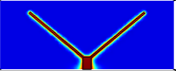 | 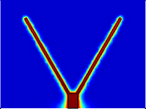 | 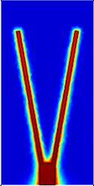
- Middle fin cross section: 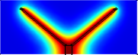 | 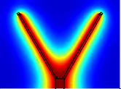 | 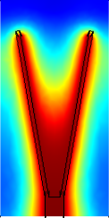
- Ending fin cross section: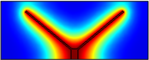 | 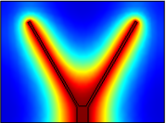 | 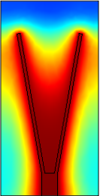
Fig. 6.11. Domain temperature for Cases 13-15 [K]

Case 13 | Case 14 | Case 15
- First fin cross section: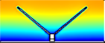 | 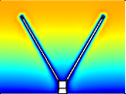 | 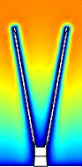 | 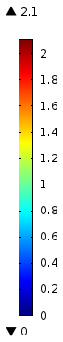
- Middle fin cross section: 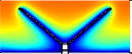 | 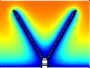 | 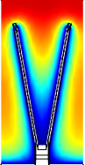
- Ending fin cross section: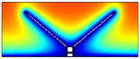 | 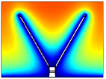 | 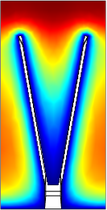
Fig. 6.12. Domain velocity for Cases 13-15 [m/s]
Cases 16-18. Cases 16, 17 and 18 regards the modelling of assembly characterized by an aspect ratio of $φ$ = 0.20 subjected to a laminar inflow at 3 m/s. The modelling results are aligned to those of Cases 4-6 ($φ$ = 0.10), and Cases 10-12 ($φ$ = 0.15) with better thermal performance guaranteed by more high-conductive material used. The highest velocity permits in general to reach better dissipative effects in comparison to Cases 13-15, with more developed temperature field (Fig. 6.13) and velocity field (Fig. 6.14). Case 16 ($α$ = 40°) and Case 17 ($α$ = 60°) show almost the same dimensionless heat flux ($\tilde{q}$ = 0.00756). Case 18 ($α$ = 80°) is characterized by the highest $\tilde{q}$, equal to 0.00794 (+5.0%).
Table 6.8. Numerical results for Cases 16-18
Case 16 ($φ$ = 0.20, $α$ = 40°, $\overline{u}$ = 3 m/s)
Laminar flow | $$Re$$ | 2021.6 | (-)
Momentum b.l. | $$δ$$ | 2.77E-04 | (m)
Mesh | n. o. e. | 1'297'959 | (-)
Dim. heat flux | $$\tilde{q}$$ | 0.00756 | (-)
Total heat flux | Q | 6.3034 | (W)
Heat transfer coefficient | $$\overline{h}$$ | 45.05 | (W/m² K)
Case 17 ($φ$ = 0.20, $α$ = 60°, $\overline{u}$ = 3 m/s)
Laminar flow | $$Re$$ | 2074.8 | (-)
Momentum b.l. | $$δ$$ | 2.81E-04 | (m)
Mesh | n. o. e. | 1'125'314 | (-)
Dim. heat flux | $$\tilde{q}$$ | 0.00756 | (-)
Total heat flux | Q | 6.3962 | (W)
Heat transfer coefficient | $$\overline{h}$$ | 44.62 | (W/m² K)
Case 18 ($φ$ = 0.20, $α$ = 80°, $\overline{u}$ = 3 m/s)
Laminar flow | $$Re$$ | 1355 | (-)
Momentum b.l. | $$δ$$ | 2.27E-04 | (m)
Mesh | n. o. e. | 975'572 | (-)
Dim. heat flux | $$\tilde{q}$$ | 0.00794 | (-)
Total heat flux | Q | 6.8145 | (W)
Heat transfer coefficient | $$\overline{h}$$ | 46.22 | (W/m² K)
Figure 6.15 reports the dimensionless heat flux $\tilde{q}$ of the Y-shaped assemblies so far analyzed. Once again, the most performing assemblies are denoted by high $φ$. Also, the effect of varying the angle $α$ was significant only for inlet velocity of 3 m/s, while air flows at 1 m/s have proved to have almost a same effect on constructs characterized by different shape, for a given volume ratio $φ$. However, a subtle point can be highlighted: at the lowest inlet velocity, the constructs with an angle $α$ = 80° when passing from $φ$ = 0.10 (Case 3) to $φ$ = 0.20 (Case 15) throughout $φ$ = 0.15 (Case 9), show, respectively, the worst, the average and the better thermal performance in comparison to their equivalent cases. On the other hand, given the inlet velocity of 1 m/s, for a given $φ$ there is no relevant difference between the constructs with $α$ = 40° (Cases 1, 7, 13) and those with $α$ = 60° (Cases 2, 8, 14)
Case 16 | Case 17 | Case 18
- First fin cross section: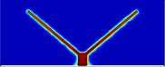 | 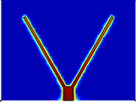 | 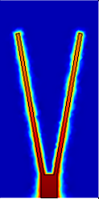
- Middle fin cross section: 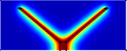 | 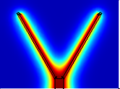 | 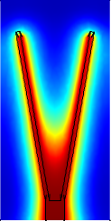
- Ending fin cross section: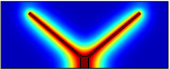 | 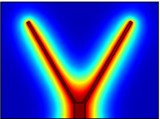 | 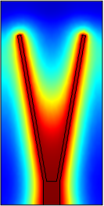
Fig. 6.13. Domain temperature for Cases 13-15 [K]
Given these considerations, we can argue that, in case of low $Re$ the optimal Y shape tends to be flat (i.e. tributaries horizontally extended) when the aspect ratio $φ$ is low (Cases 1-3 and 7-9).
The Y-shaped assembly has proved to be particularly performing in case of more sizable velocity fields: the fluid-thermodynamic modelling showed how, in case of average inlet velocity of 3 m/s the heat removal enhances when $α$ increases, for every $φ$ considered when passing from $α$ = 60° to $α$ = 80°: from Case 5 to 6 ($φ$ = 0.10)
Case 16 | Case 17 | Case 18
- First fin cross section: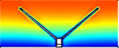 | 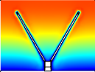 | 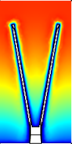 | 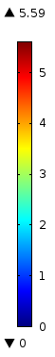
- Middle fin cross section: 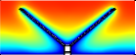 | 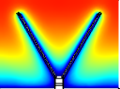 | 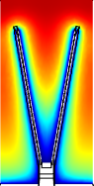
- Ending fin cross section: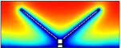 | 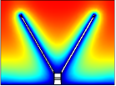 | 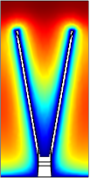
Fig.6.14. Domain velocity for Cases 16-18 [m/s]
$\tilde{q}$ increases of 4.2%, of 4.4% passing from Case 11 to Case 12 ($φ$ = 0.15), and finally of 4.5% from Case 17 to Case 18 ($φ$ = 0.20).
In conclusion, the Y-shape fin seems to be an appropriate construct when the environment is characterized by a considerable high convective contribute, as its thermal performance increases when it shows narrower tributaries, i.e. higher values for the angle $α$.
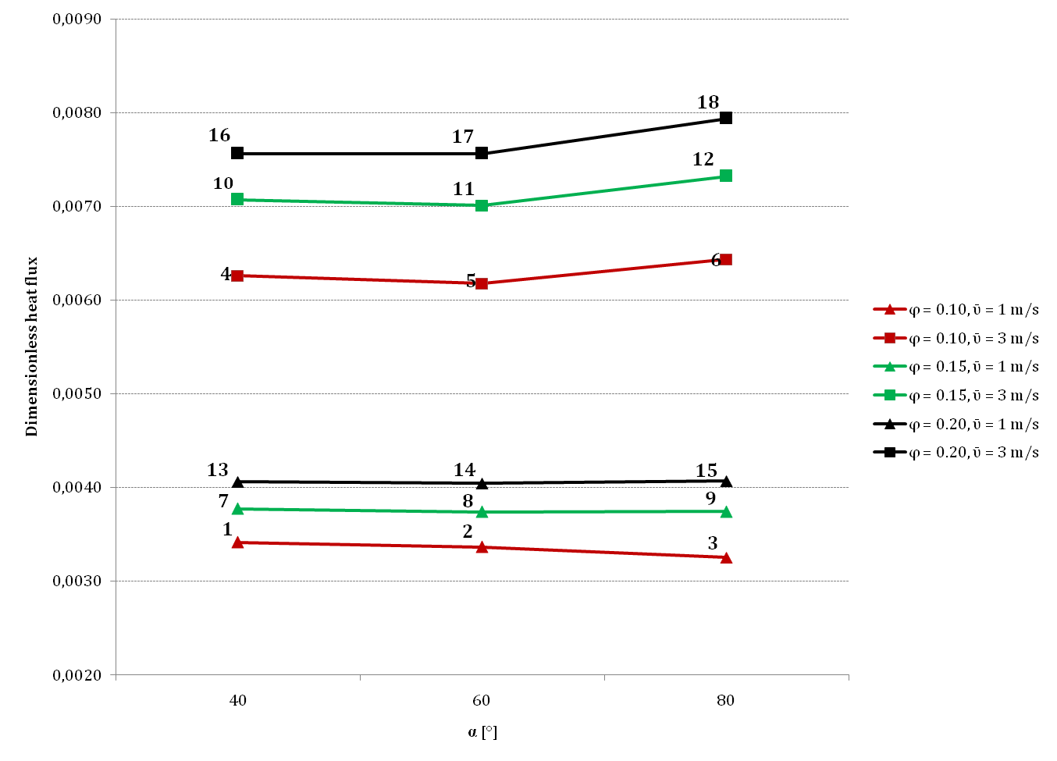
Fig.6.15. Dimensionless heat flux for Y-shaped convective fins - Laminar flow
In the next section we will analyze a convective environment characterized by higher $Re$: the inlet velocity will be augmented to 5 and 7 m/s and the performance of Y-shaped assemblies at the changed conditions will be discussed.

6.5 Conjugate heat transfer in turbulent flow conditions
Governing equations
The variables to solve in the thermo-fluid-dynamic modelling are velocity, pressure and temperature. In order to treat inlet air velocities of 5 m/s, it has been necessary to change the model settings from laminar flow to turbulent flow, as $Re$ calculated at the air inlet exceeded too much the value of 2000. Both the governing equations and the assumptions made about the thermo-physical properties of the materials are roughly the same of those reported in §6.4: for the air domain, the mass conservation reported in Eq.(6.4) is still valid. For the momentum conservation we have adopted a Reynolds-Averaged Navier-Stokes (RANS), which is a particular instance of the typical Navier-Stokes equation, using averages velocity and pressure fields. The momentum equation formulation is as follows:
$ρ\left(\vec{u}∙∇\right)\vec{u}+∇p-(μ+μ_{T})\left(∇\vec{u}+{\left(∇\vec{u}\right)}^{T}\right)=0$ (6.12)
Where the term $μ_{T}$ represents the turbulent viscosity, i.e. the effects of the small-scale velocity fluctuations that are not solved for by the RANS equations. The turbulent viscosity $μ_{T}$ can be evaluated by means of specific turbulence models. In this work the algebraic turbulence model L-VEL was adopted as it is well known for providing good approximations for internal flows, especially in electronic cooling applications.
It computes the turbulent viscosity basing only on the local fluid velocity and the distance to the closest wall, without considering any additional variable. At this regard, it can be considered one of the least accurate model comparing it with the other (Spalart-Allmaras, k-ε, k-ω, and their combinations), but, on the other hand it solves the model everywhere in the flow domain and does not use wall functions. Therefore, coupled with a good mesh it can be considered suitable for the flux application. The main idea of the L-VEL framework is that it can be presumed the existence of a general velocity profile connecting the distance from the wall, and the velocity. A general energy equation similar to Eq.(6.6) is also used. The turbulence framework entails the use of two additional variables to the model, called reciprocal wall distance $G$ and tangential velocity in viscous units $uPlus$, both of them dimensionless.
Boundary conditions and initial settings
All the b.c.'s, material properties and flow characteristics are equal to those adopted for the laminar modelling (see Table 6.1). The only one exception is represented by the flow inlet where a normal inflow velocity of 5 m/s was imposed for each test.
Mesh definition
When a turbulent flow is present, the mesh should be fine enough to resolve the size of the smallest eddies in the flow itself. For the fluid-dynamic domain, the mesh was defined according to the thickness of the momentum boundary layer (for air $δ≪δ_{t}$). The minimum element size was hence fixed equal to$δ$, calculated using Eq.(6.7), while the maximum element size was arbitrarily at 2$δ$. In addition, a boundary layer mesh characterized by only two layers was used, as the velocity field do not change quite rapidly in the normal direction to the fin walls.
Results
Three kinds of Y-shaped fins characterized by three values of$α$ (40°, 60°, 80°), at $φ$ = 0.15 have been investigated; the inlet velocities considered are now 5 and 7 m/s. The Reynolds number calculated at the inlet fully justified the adoption of a turbulent flow analysis. The dimensional heat flux and the heat transfer coefficient are calculated, using Eqs.(6.10) and (6.11), respectively.
Cases 19-21
The modelling results are shown in Tables 6.9, while Figures 6.16 and 6.17 show, respectively, the related temperature and velocity fields. The high $Re$ for Cases 19 and 20 justify the adoption of the turbulence modelling while Case 21 shows initially a $Re$ = 2007 that could define either a transitional or a laminar inflow; however we could expect a higher $Re$ along the fin walls as velocities tend to increase (Fig.6.17).
Table 6.9. Numerical results for Cases 19-21
Case 19 ($φ$ = 0.15, $α$ = 40°, $\overline{u}$ = 5 m/s)
Turbulent flow | $$Re$$ | 3129.8 | (-)
Momentum b.l. | $$δ$$ | 2.07E-04 | (m)
Mesh | n. o. e. | 2'600'786 | (-)
Dim. heat flux | $$\tilde{q}$$ | 0.01028 | (-)
Total heat flux | Q | 7.7333 | (W)
Heat transfer coefficient | $$\overline{h}$$ | 66.99 | (W/m² K)
Case 20 ($φ$ = 0.15, $α$ = 60°, $\overline{u}$ = 5 m/s)
Turbulent flow | $$Re$$ | 3159.2 | (-)
Momentum b.l. | $$δ$$ | 2.08E-04 | (m)
Mesh | n. o. e. | 2'322'434 | (-)
Dim. heat flux | $$\tilde{q}$$ | 0.01029 | (-)
Total heat flux | Q | 7.8294 | (W)
Heat transfer coefficient | $$\overline{h}$$ | 66.58 | (W/m² K)
Case 21 ($φ$ = 0.15, $α$ = 80°, $\overline{u}$ = 5 m/s)
Transition flow | $$Re$$ | 2006.5 | (-)
Momentum b.l. | $$δ$$ | 1.66E-04 | (m)
Mesh | n. o. e. | 1'993'531 | (-)
Dim. heat flux | $$\tilde{q}$$ | 0.01049 | (-)
Total heat flux | Q | 6.8145 | (W)
Heat transfer coefficient | $$\overline{h}$$ | 66.66 | (W/m² K)

Case 19 | Case 20 | Case 21
- First fin cross section: 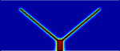 | 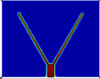 | 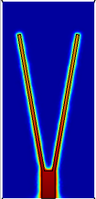
- Middle fin cross section: 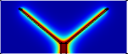 | 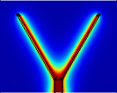 | 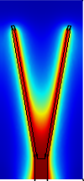
- Ending fin cross section: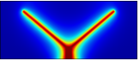 | 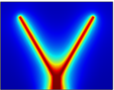 | 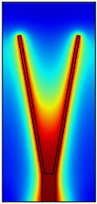
Fig.6.16. Domain temperature for Cases 19-21 [K]
The b.l. is now very thin in comparison to previous cases and the mesh is very dense, especially in Case 21.
The dimensionless heat flux is higher than previous cases at lower velocities; Cases 19 ($α$ = 40°), and 20 ($α$ = 60°) are denoted by an almost equal $\tilde{q}$, respectively 0.01028 and 0.01029, while Case 21 ($α$ = 80°) is characterized by the highest flux even with a little difference (+1.9%) with respect to Case 20.
Case 19 | Case 20 | Case 21
- First fin cross section: 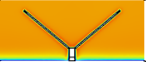 | 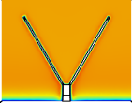 | 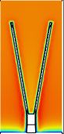 | 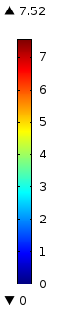
- Middle fin cross section: 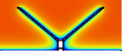 | 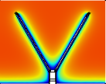 | 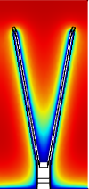
- Ending fin cross section: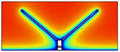 | 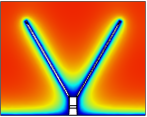 | 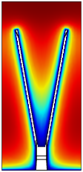
Fig. 6.17. Domain velocity for Cases 19-21 [m/s]
Figure 6.18 shows the velocity streamlines tangential to the velocity vector; the view, normal to the inlet velocity, is located at the beginning of the channel. As one can note, the streamlines tend to produce whirls in correspondence of the frontal area of the constructs. Also, as $α$ increases the streamlines bend more irregularly.

(Case 19)  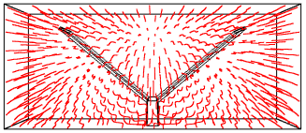 | (Case 21)  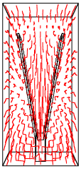
(Case 20)
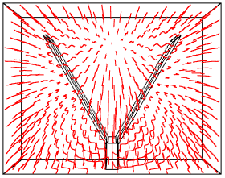
Fig.6.18. Velocity streamlines ($φ$ = 0.15, $\overline{u}$ = 5 m/s)
Cases 22-24
Cases 22, 23 and 24 regard the modelling of turbulent inflows at 7 m/s. The results are shown in Tables 6.10, while Figures 6.19 and 6.20 show, respectively, the related temperature and velocity fields. Reynolds number are now considerably high with respect to Cases 19-21, therefore the adoption of the turbulence modelling is fully justified. The b.l.'s are very thin (between 0.14 mm and 0.176 mm) and as a consequence the mesh are very dense, especially in Case 22.
The dimensionless heat flux is higher than previous cases at 5 m/s; Cases 22 ($α$ = 40°), and 23 ($α$ = 60°) are denoted by an almost equal $\tilde{q}$, respectively 0.01270 and 0.01271, while Case 24 ($α$ = 80°) is characterized by the highest flux even with a little difference (+3.5%) with respect to Case 23.
Figure 6.21 shows the velocity streamlines tangential to the velocity vector for Cases 22-24 which are slightly more irregular in comparison to Cases 19-21: only in the vicinity of the channel walls Cases 22 and 23 show quite straight velocity flows. Even in this case, as $α$ increases the streamlines bend more irregularly.

Table 6.10. Numerical results for Cases 22-24
Case 22 ($φ$ = 0.15, $α$ = 40°, $\overline{u}$ = 7 m/s)
Turbulent flow | $$Re$$ | 4381.7 | (-)
Momentum b.l. | $$δ$$ | 1.75E-04 | (m)
Mesh | n. o. e. | 3'953'309 | (-)
Dim. heat flux | $$\tilde{q}$$ | 0.01270 | (-)
Total heat flux | Q | 9.535 | (W)
Heat transfer coefficient | $$\overline{h}$$ | 82.60 | (W/m² K)
Case 23 ($φ$ = 0.15, $α$ = 60°, $\overline{u}$ = 7 m/s)
Turbulent flow | $$Re$$ | 4422.9 | (-)
Momentum b.l. | $$δ$$ | 1.76E-04 | (m)
Mesh | n. o. e. | 3'439'663 | (-)
Dim. heat flux | $$\tilde{q}$$ | 0.01271 | (-)
Total heat flux | Q | 9.6685 | (W)
Heat transfer coefficient | $$\overline{h}$$ | 82.22 | (W/m² K)
Case 24 ($φ$ = 0.15, $α$ = 80°, $\overline{u}$ = 7 m/s)
Transition flow | $$Re$$ | 2809.1 | (-)
Momentum b.l. | $$δ$$ | 1.4E-04 | (m)
Mesh | n. o. e. | 3'120'379 | (-)
Dim. heat flux | $$\tilde{q}$$ | 0.01316 | (-)
Total heat flux | Q | 10.154 | (W)
Heat transfer coefficient | $$\overline{h}$$ | 84.05 | (W/m² K)
Figure 6.22 reports the dimensionless heat flux $\tilde{q}$ of the Y-shaped analyzed in both laminar and turbulent regimes. All data refers to assemblies characterized by $φ$ = 0.15, therefore the discussion will be now just on the velocity and the angle effects. The effect of varying the angle $α$ was significant only for inlet velocities of 3, 5 and 7 m/s, while for an air flow at 1 m/s the change in shape did not influenced significantly the thermal performance. Passing from $α$ = 60° to $α$ = 80° causes an increase in the dimensionless heat flux of 4.4%, 1.9% and 3.5%, respectively for inlet velocity of 3, 5 and 7 m/s (Cases 11-12, 20-21, 23-24). Also, given the previous considerations, we could expect the same tendency, even more emphasized for higher $φ$.
The Y-shape construct proves to be appropriate when the environment is characterized by a considerable high convective contribute. The results highlight how it tend to realize a better performance in the vicinity of $α$ = 80° rather than lower values for $α$, and such behavior confirms the literature results.

Case 22 | Case 23 | Case 24
- First fin cross section: 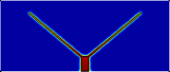 | 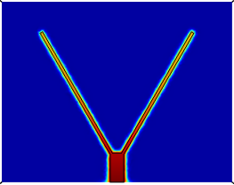 | 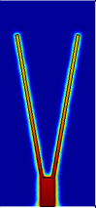
- Middle fin cross section: 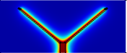 | 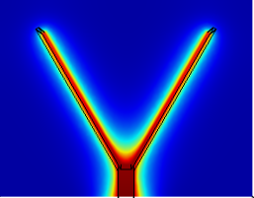 | 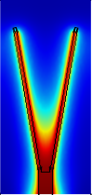
- Ending fin cross section: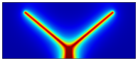 | 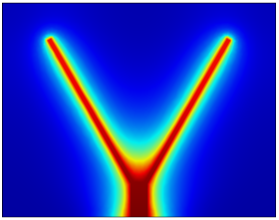 | 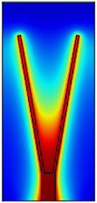
Fig.19. Domain temperature for Cases 22-24 [K]

Case 22 | Case 23 | Case 24
- First fin cross section: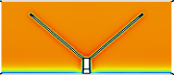 | 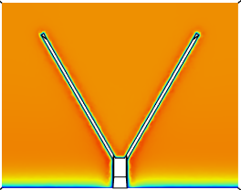 | 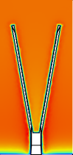 | 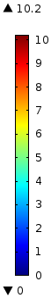
- Middle fin cross section: 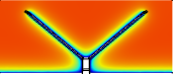 | 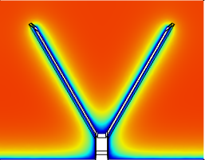 | 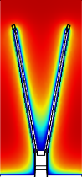
- Ending fin cross section: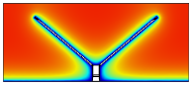 | 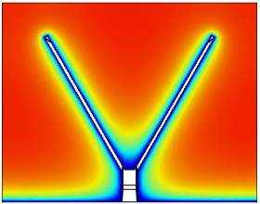 | 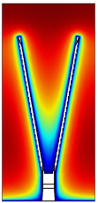
Fig. 6.20. Domain velocity for Cases 22-24 [m/s]

(Case 22)  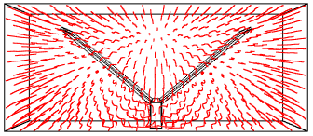 | (Case 24)  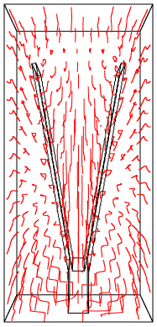
(Case 23)
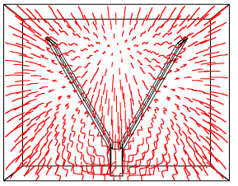
Fig.6.21. Velocity streamlines ($φ$ = 0.15, $\overline{u}$ = 7 m/s)

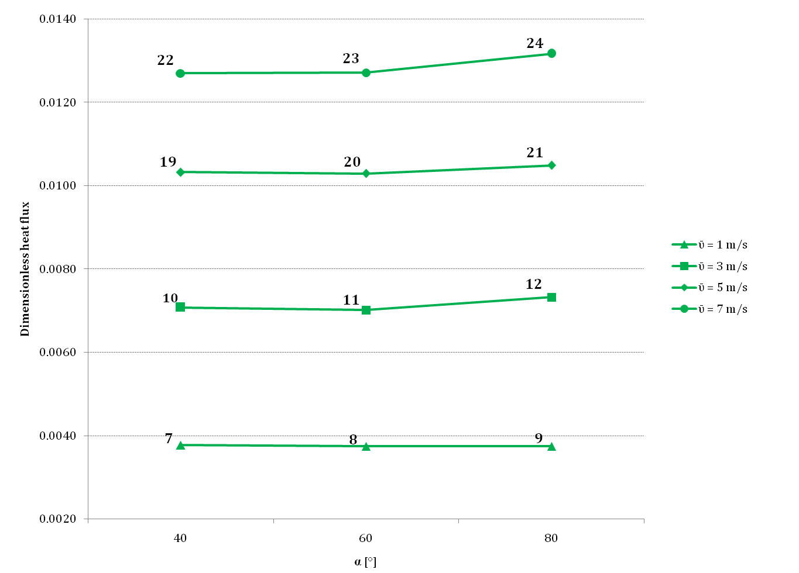
Fig. 6.22. Dimensionless heat flux for Y-shaped convective fins - Laminar and turbulent flow

References
A. Bejan, Heat Transfer, John Wiley & Sons, 1985.
A. Esmaeilnejad, H. Aminfar, M.S. Neistanak, Numerical investigation of forced convection heat transfer through microchannels with non-Newtonian nanoﬂuids, Int. J. Therm. Sci. 75, pp. 76–86, 2014.
R.W. Knight, J.S. Goodling, D.J. Hal, Optimal thermal design of forced convection heat sinks-analytical, ASME J. Electron. Packag. 113, pp. 313–321, 1991.
Y.L. Li, F.L. Zhang, G.N. Xie, B. Sundén, Laminar thermal performance of microchannel heat sinks with constructal vertical Y-shaped bifurcation plates, Appl. Therm. Eng. 73, pp. 185–195, 2014.
G. Lorenzini, S. Moretti, Numerical analysis of heat removal enhancement with extended surfaces, Int. J. Heat Mass Transfer 50, pp.746–755, 2007.
R. Mahajan, R. Nair, V. Wakharkar, Emerging directions for packaging technologies, Intel Technol. J. 6, pp.104–112, 2002.
M. Mital, Analytical analysis of heat transfer and pumping power of laminar nanoﬂuid developing ﬂow in microchannels, Appl. Therm. Eng. 50, pp. 429–436, 2013.
A. Rezania, L.A. Rosendahl, S.J. Andreasen, Experimental investigation of thermoelectric power generation versus coolant pumping power in a microchannel heat sink, Int. Commun. Heat Mass Transfer 39, pp.1054–1058, 2012.
Senn, S. M., Poulikakos, D., Laminar Mixing, Heat Transfer and Pressure Drop in Tree-Like Microchannel Nets and their Applications for Thermal Management In Polymer Electrolyte Fuel Cell, Journal of Power Sources, 130, pp.178-191, 2004.
H. Shafeie, O. Abouali, K. Jafarpur, Numerical study of heat transfer performance of single-phase heat sinks with micro pin-ﬁn structures, Appl. Therm. Eng. 58, pp. 68–76, 2013.
D.B. Tuckerman, R.F.W. Pease, High-performance heat sinking for VLSI, IEEE Electron Device Lett. 2, pp.126–129, 1981.
G.N. Xie, H. Shen, C.C. Wang, Parametric study on thermal performance of microchannel heat sinks with internla vertical Y-shaped bifurcations, Int. J. Heat and Mass Transfer, 90, pp. 948-958, 2015.
G.N. Xie, F.L. Zhang, B. Sundén, W.H. Zhang, Constructal design and thermal analysis of microchannel heat sinks with multistage bifurcations in singlephase liquid ﬂow, Appl. Therm. Eng. 62, pp. 791–802, 2014.

7

Conclusions

7.1 Final remarks

In this work the problem to find the optimal geometry of T and Y-shaped assemblies of fins was addressed. At first the analysis, based on pure conduction models, focused on set of geometric parameters to optimize such as: the fin volume constraint $φ$ that defines the amount of the high conductive material that the fin use; a positive correlation between $φ$ and heat transfer has been always verified: the more solid material is employed within a conductive-dominant heat transfer environment, the more heat flux is high through the root of the fin; on the other hand, it is possible to benefit from a cost reduction using less optimized material, and for this reason the range studied for $φ$ was [0.10 - 0.20]. Every assembly was characterized also by $t_{1}/t_{0}$, a geometric parameter defining the ratio between the thickness of the arms and that of the steam of the fin; in particular, fins characterized by a ratio $t_{1}/t_{0}$ = 5 have demonstrated to be the most performing with respect to the other studied ratios $t_{1}/t_{0}$. The geometric ratio $L_{1}/L_{0}$, defined as the ratio between the length of the arms and the length of the steam showed a strong dependency on $φ$ according to the numerical values investigated: the optimal ratio $L_{1}/L_{0}$ switched to high values at low $φ$ (i.e. 0.27 at $φ$ = 0.10) to lower values as $φ$ increases (0.21 at $φ$ = 0.15 and 0.17 at $φ$ = 0.20). Such tendency highlights that the most performing assemblies in case of less high conductive material used are those whose wetted surface is more extended. In general, the most performing fins at low $φ$, which means low high-conductive material used, are those characterized by a more extended wetted surface, while as $φ$ increases, then the wetted surface tends to reduce. Low values for $φ$ are associated to less wide fins, more suitable for spaces where wide heat sinks cannot be used. It was found that the most effective and efficient fins were those characterized by low values of $φ$. Aimed at finding more performing assemblies starting from the initial T shape, another parameter was introduced, the angle $α$ with the horizontal line, defining the inclination of the arms of the fin; literature offered two important points verified in this work: first, the optimized Y-shaped assembly is characterized by lower geometric ratios $L_{1}/L_{0}$ lower in comparison to those of T-shaped fins; also, the most performing assemblies are characterized by high values of $α$. At this regard it was noted how, for each given $φ$, the heat flux decreases up to about 43° then increases almost asymptotically with the increasing of $α$. A minimum value for$\tilde{q}$ is located in the vicinity of 40° for every $φ$. An unexpected behavior was noted for assemblies at $φ$ = 0.17 as their thermal performance is worse than assemblies at $φ$ = 0.15 for $α$ ≥ 43°. Given the studied conditions, optimal Y-shape constructs can be recommended only for $α$ greater than 80°. However the numerical results obtained have highlighted some problems related to the determination of the convective heat transfer $\overline{h}$ used to address heat transfer models based on pure heat conduction, treating the convection as boundary condition. It was hence necessary to perform further researches about the convective heat transfer to which the assembly is subjected, investigating also the fluid flow characteristics. It was decided to keep on working on the Y-shaped assembly, as it promised a more performing behavior in terms of heat dissipation. Therefore the problem to find optimal shape for Y-shaped assemblies was addressed numerically by means of conjugate heat transfer. It is important to point out that in this work different geometries have been studied, with comparisons performed between fins characterized by a same value for $φ$; this aspect, surprisingly, did not clearly emerged in the literature analysis, as a large amount of works did not pay attention in the analysis and in the comparison of constructs made of same amount of material.

In the conjugate heat transfer modelling performed, the computational domain consisting of a rectangular straight channel, determined after suitable tests as a good trade-off between the choose of little domains to limit the computational effort and the need to guarantee a good development of the conserving equations, was taken as computational domain; its geometry parameters have been determined after suitable tests, as a good trade-off between the choose of little domains (to limit the computational effort) vs. the need to guarantee a good development to the conserving equations. A reference value of $Re$ of 2000 was taken as reference to distinguish the laminar regime modelling from the turbulent regime modelling. The results showed how $α$ is not a critical degree of freedom for low $Re$, indeed the difference in the heat flux was not relevant for the studied geometries. Also, a connection between $φ$ and $α$ was noted, as for increasing $φ$ the most performing fins are those characterized by high values of the angle. In general, the effect of varying the angle $α$ was significant only for high inlet velocities. On the other hand, in case of low $Re$ and low $φ$ the optimal Y shape tends to be flat (i.e. tributaries horizontally extended, approaching a T shape).It is interesting to note the different behavior of the same Y-shaped fins subjected to a conjugate heat transfer environment rather than analyzed by means of a pure conduction with a pre-determined heat transfer coefficient. Figure 7.1 highlights the difference, as the latter setting tends to over-estimate the thermal performance. Also, as one can note, in the model based on pure conduction for increasing $α$ the variation of $\overline{h}$ is very large. This proves also how the assumption of constant heat transfer coefficient is not strictly accurate in case of forced convection.

Figure 7.2 shows the average Nusselt numbers as a function of Reynolds number for all the convective Y-shaped assemblies analyzed at $φ$ = 0.15; $Nu$ increases with $Re$ for each give value of $α$. As one can note, despite Cases 12, 21 and 24 are characterized by the best thermal performance for assigned inlet velocity of, respectively, 3, 5 and 7 m/s, they do not reveal the highest Nusselt numbers.

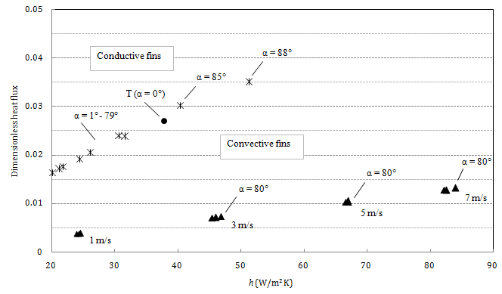

Fig. 7.1. Comparison between conductive and convective fins ($φ$ = 0.15, $a$ = 0.1)

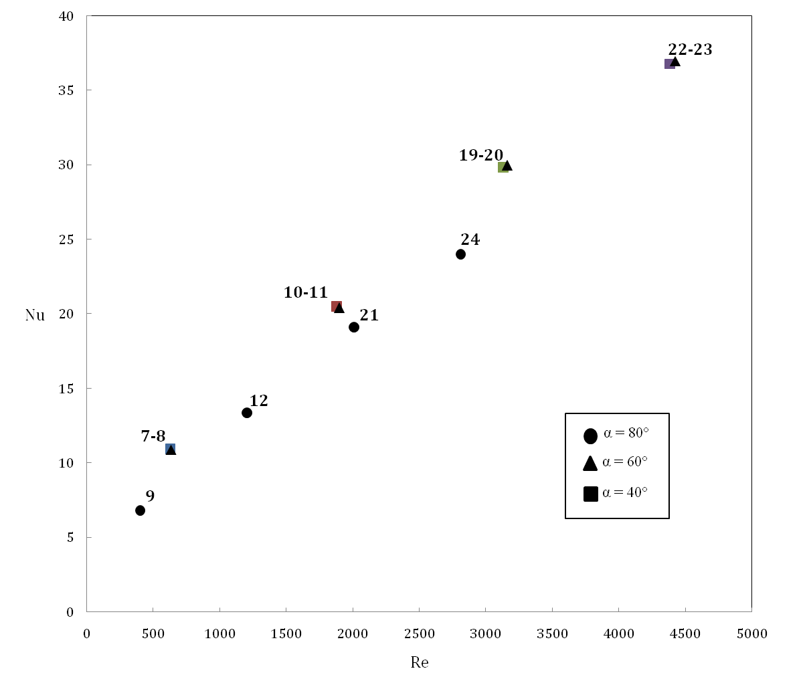

Fig. 7.2. The average Nusselt numbers of Y-shaped convective fins with Reynolds number

($φ$ = 0.15, $a$ = 0.1)

This is due the mentioned difficulty for the air flow to decrease the temperature in the area at the beginning of the fin bifurcation. However, adopting the viewpoint of electronic cooling, to justify the overall performance it would be more appropriate to use the dimensionless heat flux.

In other cases $T_{∞}$ may represent the upper limit for the temperature field within the system
The Constructal Law is a thought that the geometric form of a flow system evolves in such a way that it provides easier access to the currents that flow through it, and its method deals with the minimization of the (thermal) resistance between a volume and one point, whose essence is, in this case, filling a volume in an optimal way.
This value corresponds to the “1060” aluminum alloy

